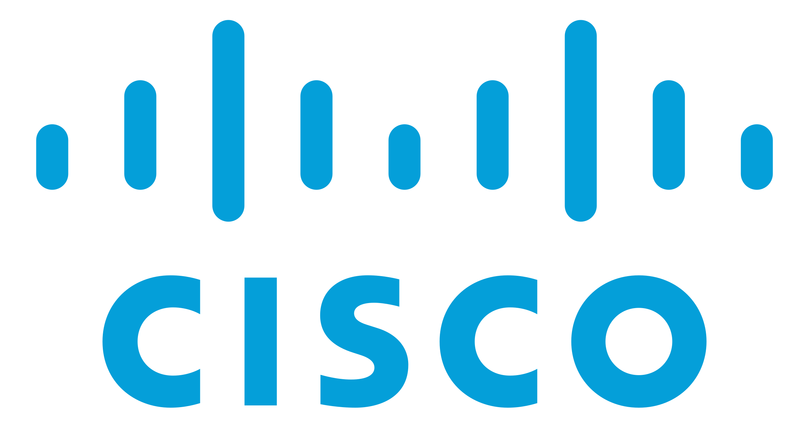

**Amazon AWS 1-3 Documentation**

Ryan Chen

12/11/2023

**Purpose:**

This lab is primarily focused on familiarization with core cloud concepts, in this case AWS virtualization. Since AWS is a leading provider of cloud computing, learning how to configure services such as AWS VPC, IAM, and EC2 has proved to be a key IT management skill and will continue to become more relevant as more companies adopt cloud computing as their primary model. Furthermore, skills in this lab such as designing user and group structures transfer over to other larger projects, such as general infrastructure design and management.

**Background Information:**

AWS is a leading cloud computing provider created by Amazon, which offers on-demand computing resources and a pay-as-you-go structure. Lately, computing architecture has increasingly shifted to become cloud based. Cloud computing presents numerous benefits over traditional on-premises servers. For instance, cloud computing allows you to reduce costs and adapt a pay for what you need style of billing. Furthermore, cloud computing allows for on demand resource allocation. This means that companies can increase or decrease the resources they pay for based on traffic at any given time. Cloud computing also brings numerous other benefits such as greater availability and fault tolerance, cost savings, and reduced configuration times. Since cloud computing hardware is managed entirely by the provider, companies no longer need to maintain their own hardware and physical servers. This enables many small companies to reduce the number of employees they need to hire, which in turn leads to overall lower operation costs.

The development of cloud computing has also been combined with virtualization to provide highly scalable, redundant, and efficient on-demand resource allocation. Virtualization is a type of technology that allows a single machine to divide its own resources and act as multiple, isolated servers. In a virtualized computing model, customers can create and destroy their own resources on demand. This also allows for greater redundancy, as customers can easily choose to migrate their system to another data center if one goes down. Furthermore, in a traditional computing model, physical servers are often not fully utilized. For instance, a server may be dedicated to run a single, low resource intensive task, which leaves the rest of the resources dormant. Virtualization fixes this problem by splitting the resources amongst numerous virtualized operating systems, which allows you to fully utilize a server by running multiple different operating systems and applications on it. Each of these systems are also isolated from the other, which provides greater redundancy and security. Finally, virtualization brings significant cost benefits, as customers can choose to use cloud providers instead of buying and maintaining their own physical servers. Cloud providers use virtualization extensively in their data centers to efficiently provide their services to many customers worldwide.

With the numerous benefits that cloud computing brings, Amazon, a leading technology company, also provides its own virtualized cloud services. Within these labs, we used IAM, VPC, and EC2, which in combination allowed us to create a structured web application hosted on AWS.

IAM (Identity and Access Management) is a service that enables administrators to securely control access to AWS services and resources. It provides a centralized way to manage AWS accounts, with features such as user creation and group/role assignment. This allows administrators to create fine-grained permission roles, which increases overall security and decreases the likelihood of a possible attacker gaining full control.

VPC (Virtual Private Cloud) is a security and network configuration service that allows customers to create a logically isolated region on AWS where they can launch resources in a virtual network. It allows for basic networking function such as subnetting, NAT translation, and public/private addressing, however, also provides more advanced features such as custom routing tables, ACLs, and VPN creation. This primarily enables customers to configure their networking, while at the same time adding an additional layer of security through isolation of their resources.

Finally, EC2 (Elastic Compute Cloud) is a service that provides resizable, on-demand compute capacity in the cloud. This service enables customers to efficiently create and destroy virtual servers and adjust resources according to their individual needs. EC2 utilizes virtualization to provide flexible and high-performance computing. Resources on EC2 can be automatically scaled depending on user needs and are also easily configurable using AMIs (Amazon Machine Image).

As a result, this lab focuses on these three key services, with the end goal being to not only learn how each service works but also utilize them by creating a simple cloud hosted web application.

**Lab 1:**

**Network Diagram:**

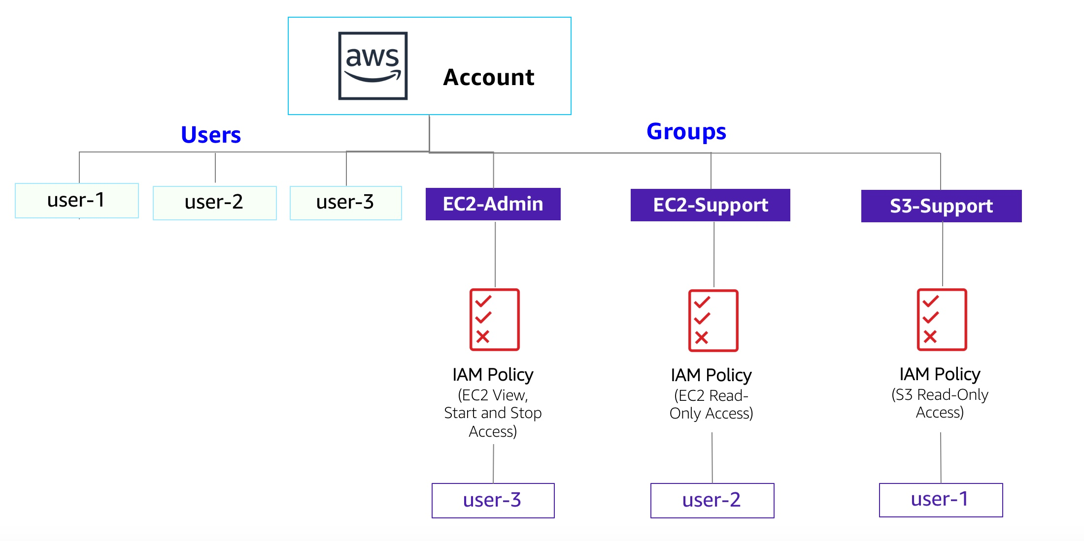 **Lab Instructions:**

The primary goal of this first lab was to provide an introduction to the AWS online interface and also the concepts and use cases of Amazon IAM, a service used to manage users.

1. Start up the AWS lab and enter the AWS Management Console. Select the IAM service within the Services menu.

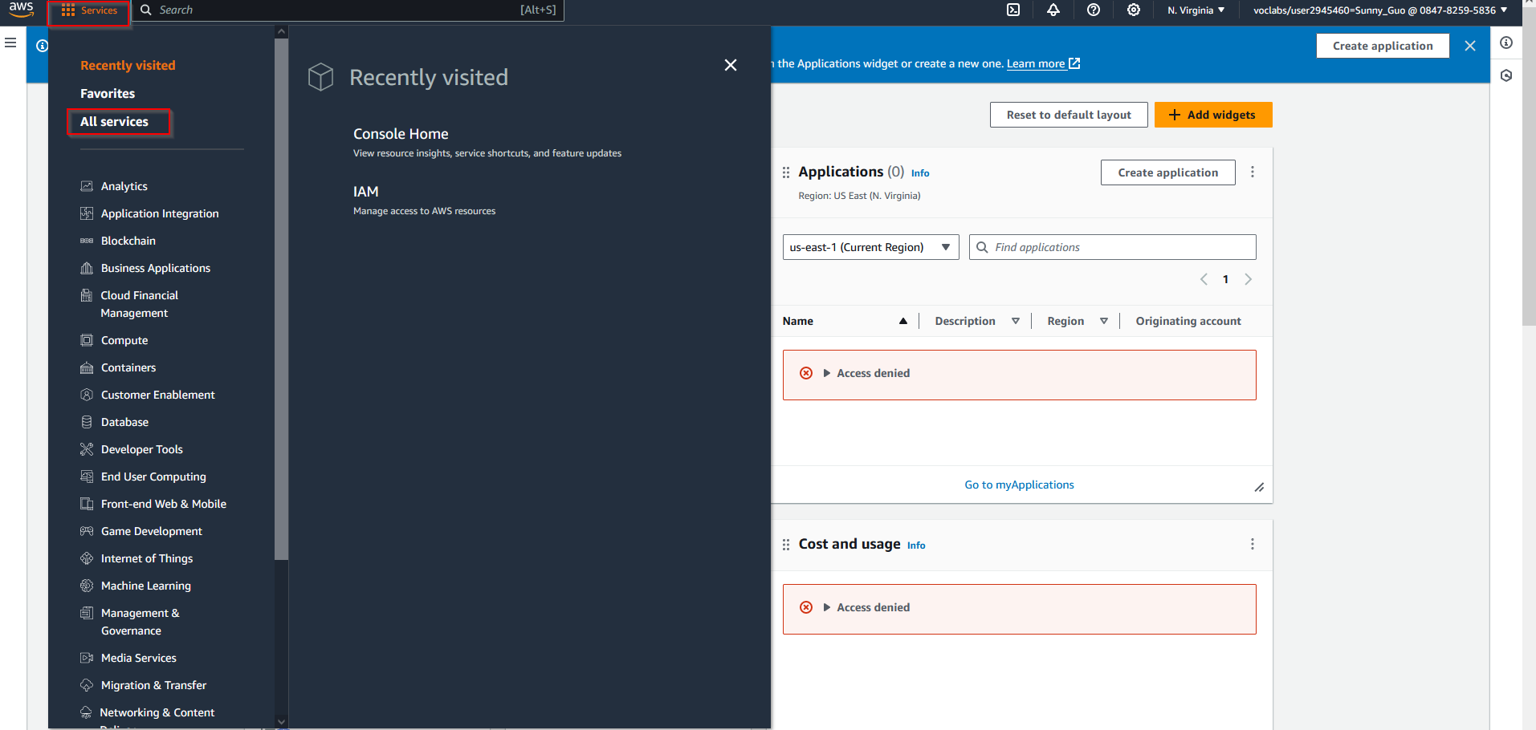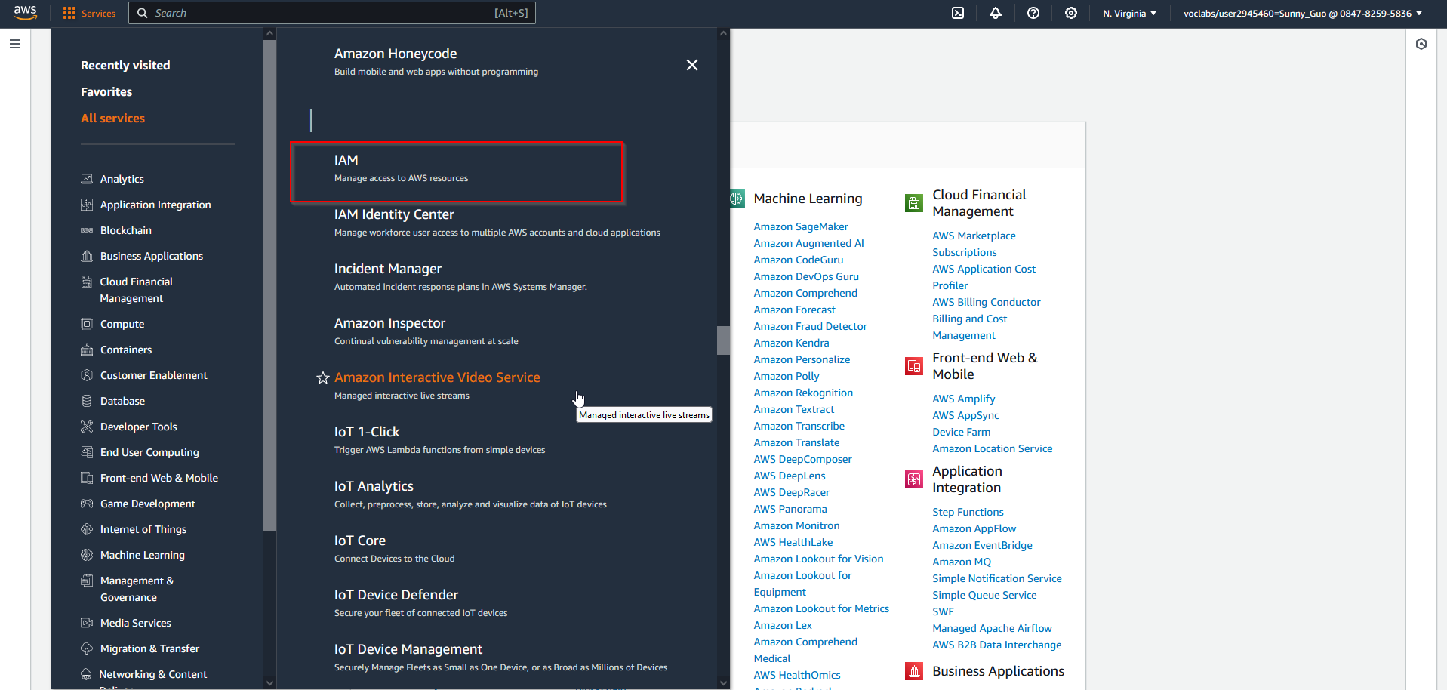

1. Go to the Users tab and observe the pre-created 3 users.

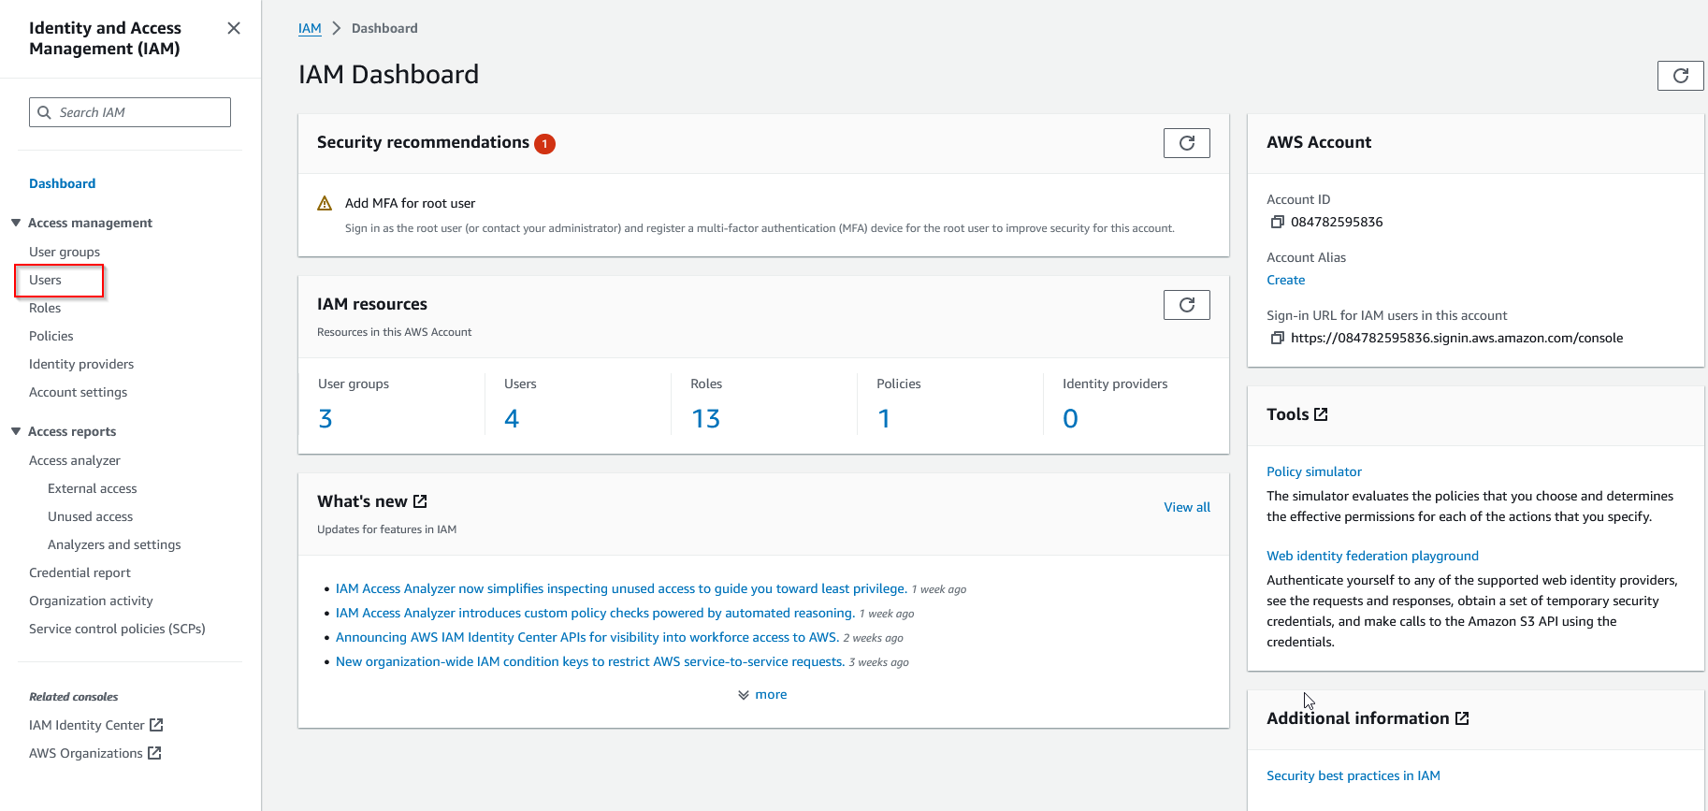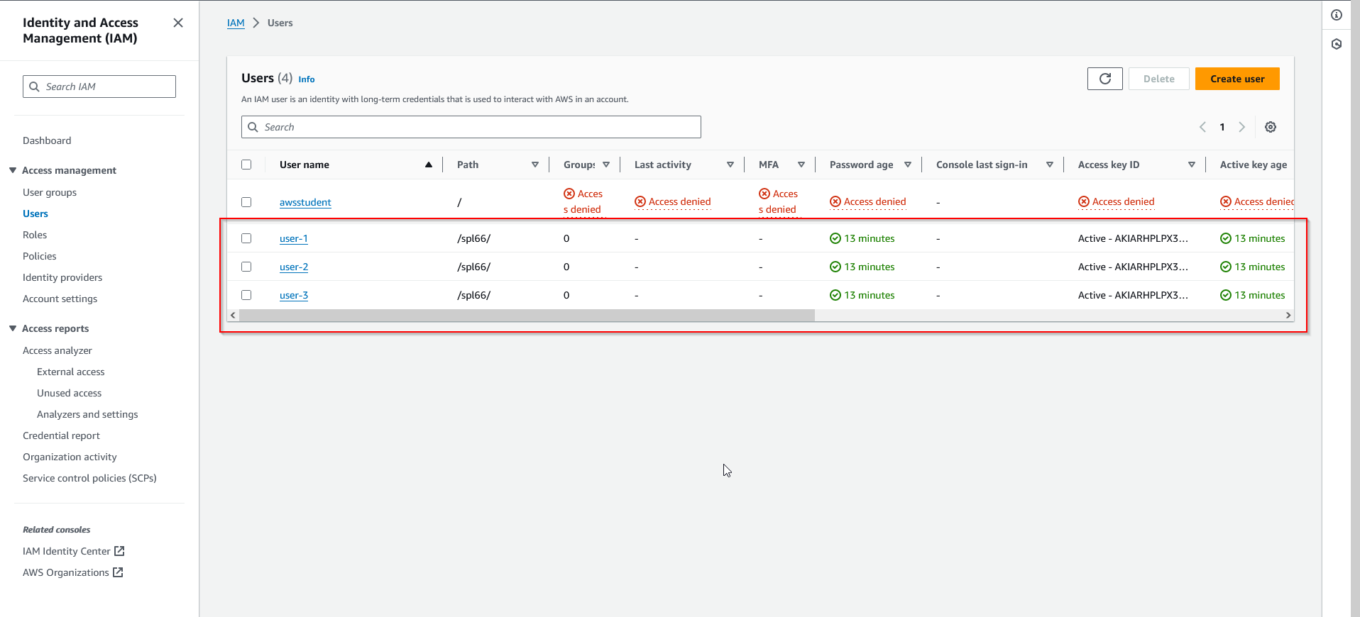

1. Choose “User-1”, then go to the Groups tab, and observe that the user is not part of any groups.

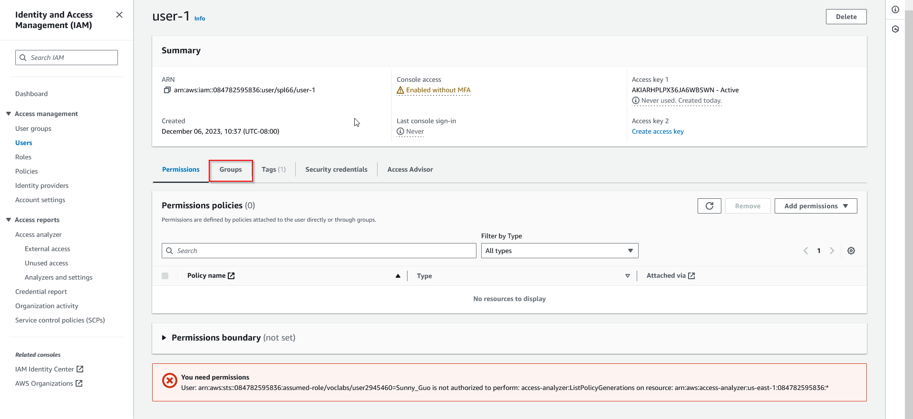

1. Go to the Security Credentials tab and observe that the user has a pre-assigned console password. 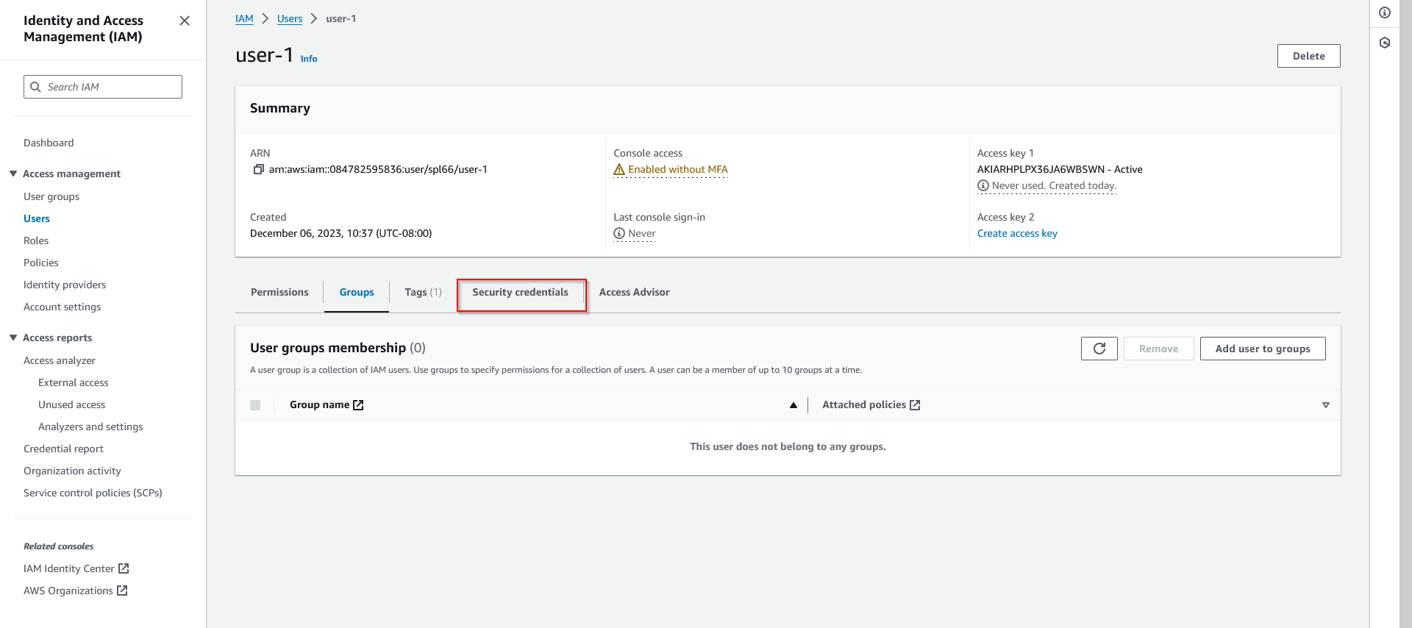
2. Navigate to the User-groups selection on the lefthand side, then choose “EC2-Support” group and observe its permissions.

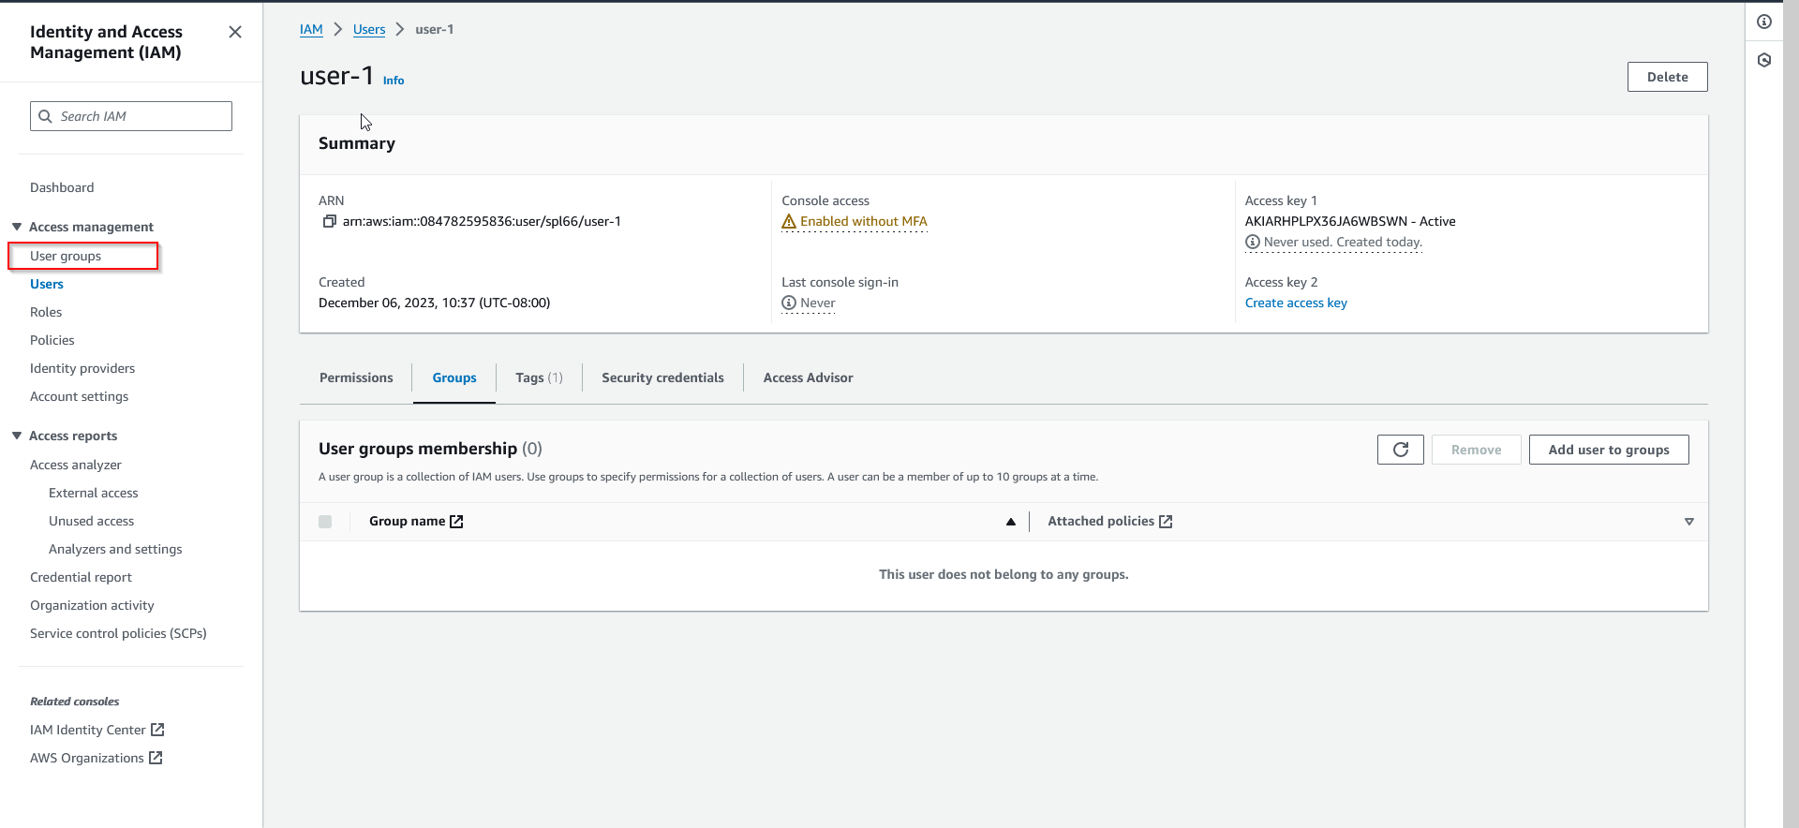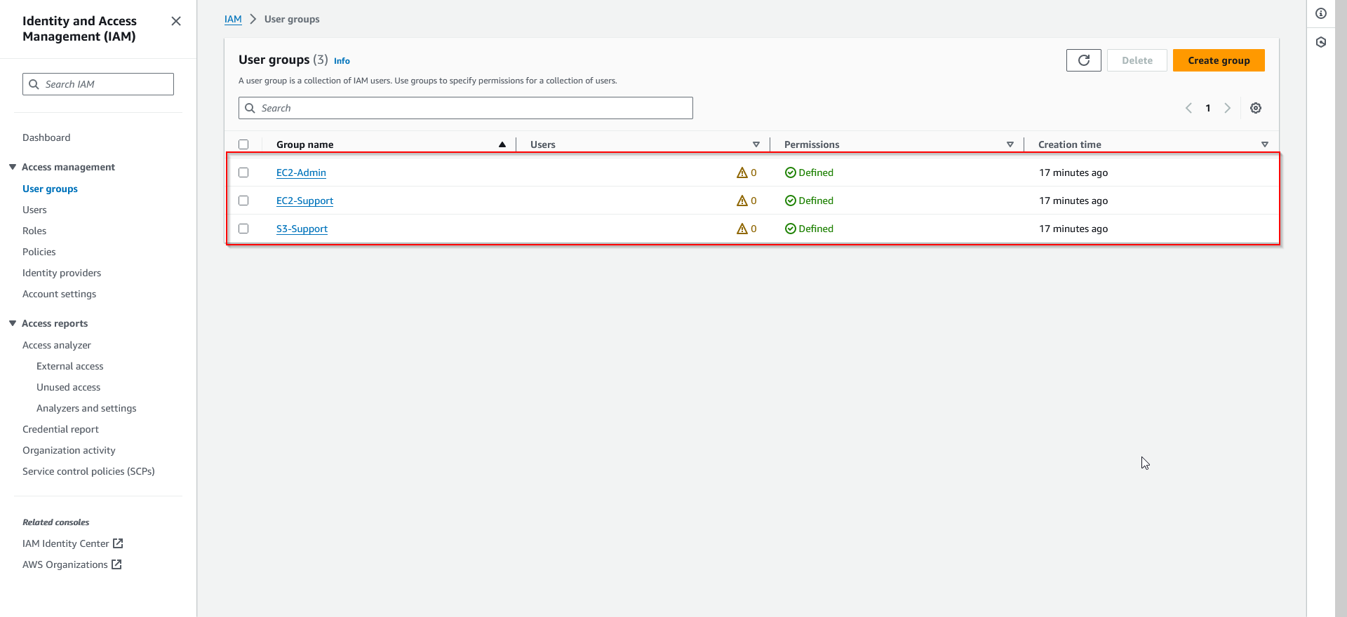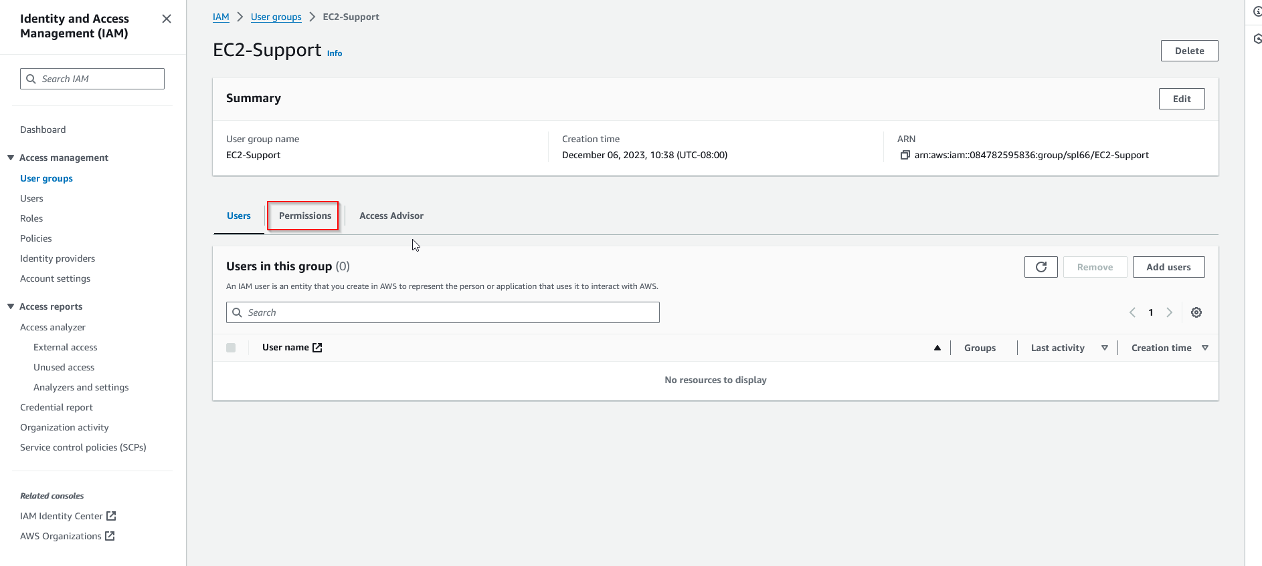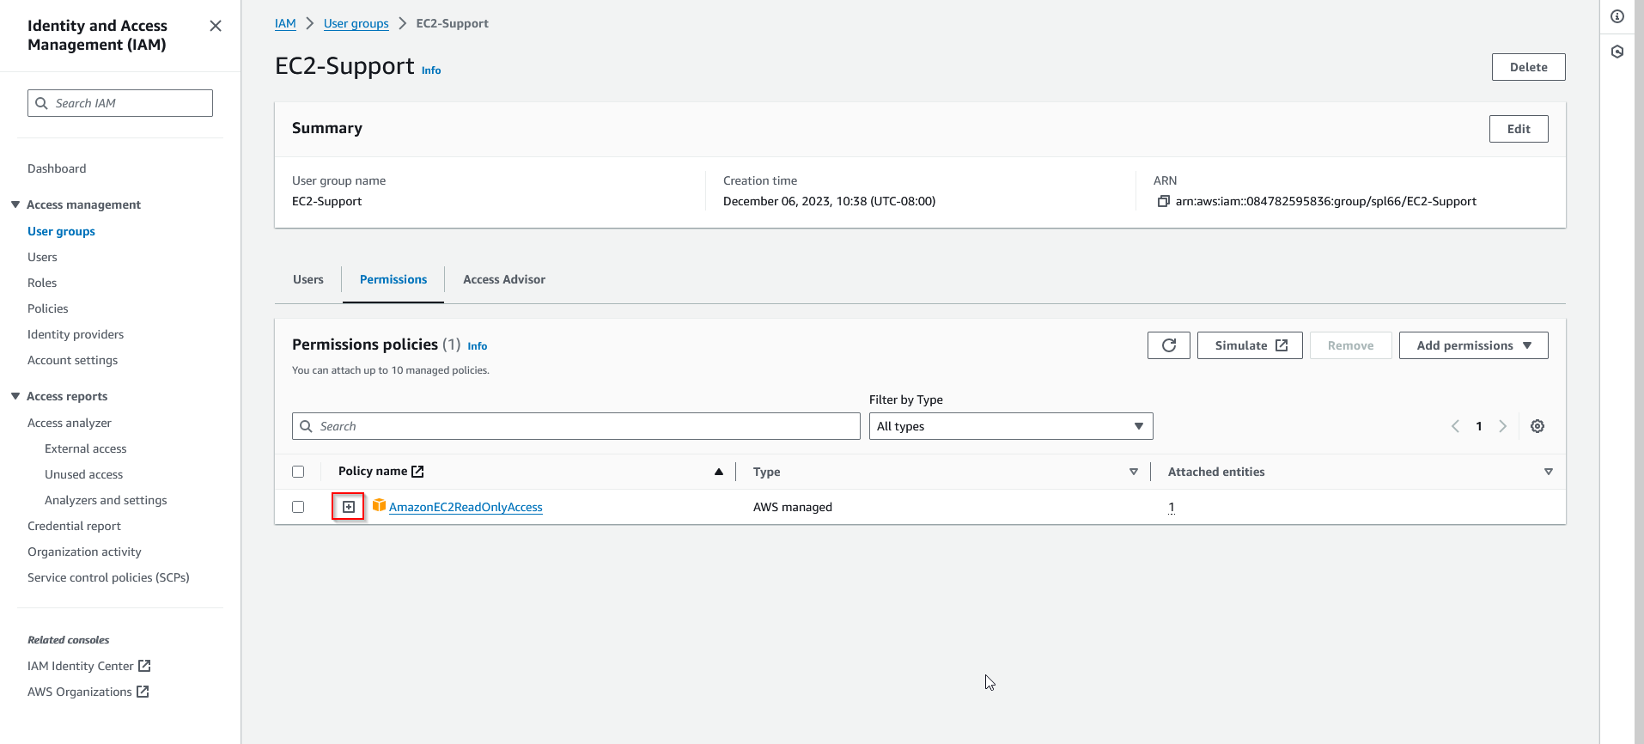

1. Observe the structure of the policy by expanding it using the (+) icon. An IAM policy is structured using three basic components: effect, action, and resource.

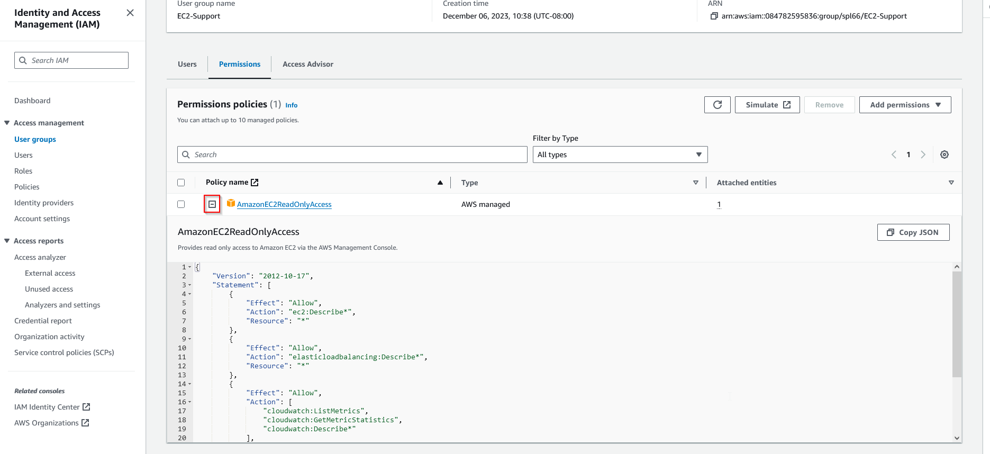

1. Go back and select “S3-Support” group, then view its permissions and policies.

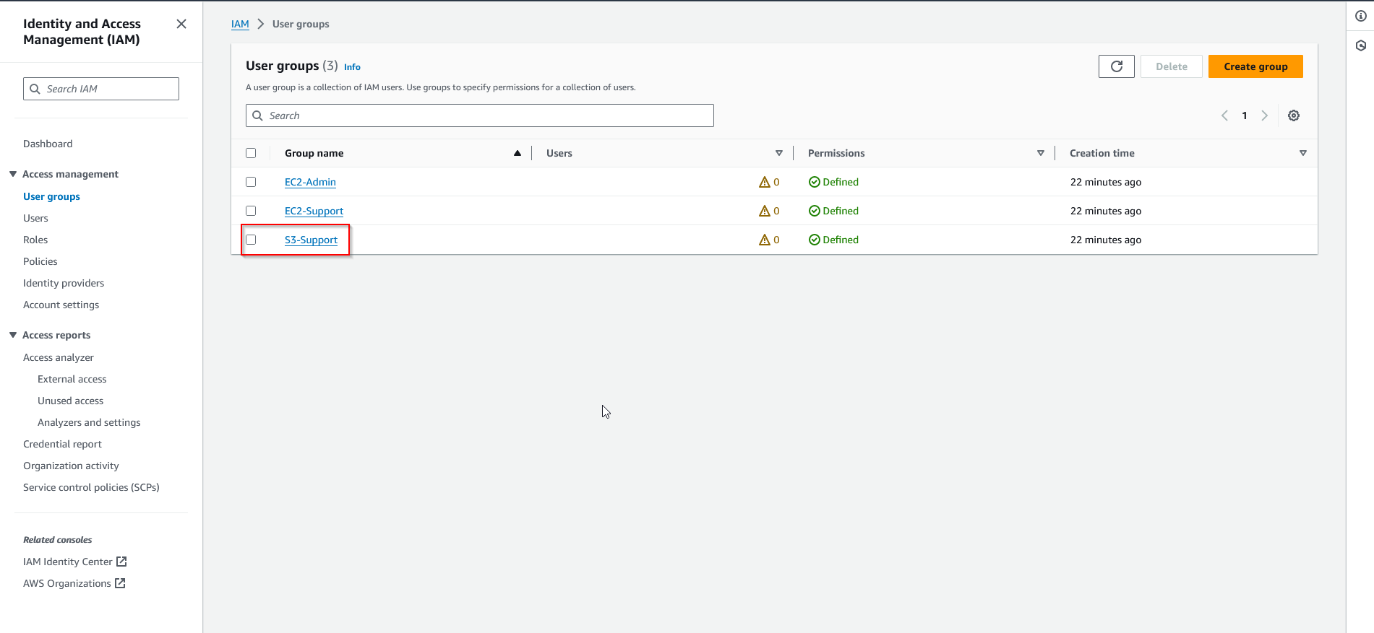

1. Go back and select “EC2-Admin” group, then view its permissions and policies. Notice that the policy is an inline policy as opposed to a managed policy, meaning it is assigned to only one User or Group.

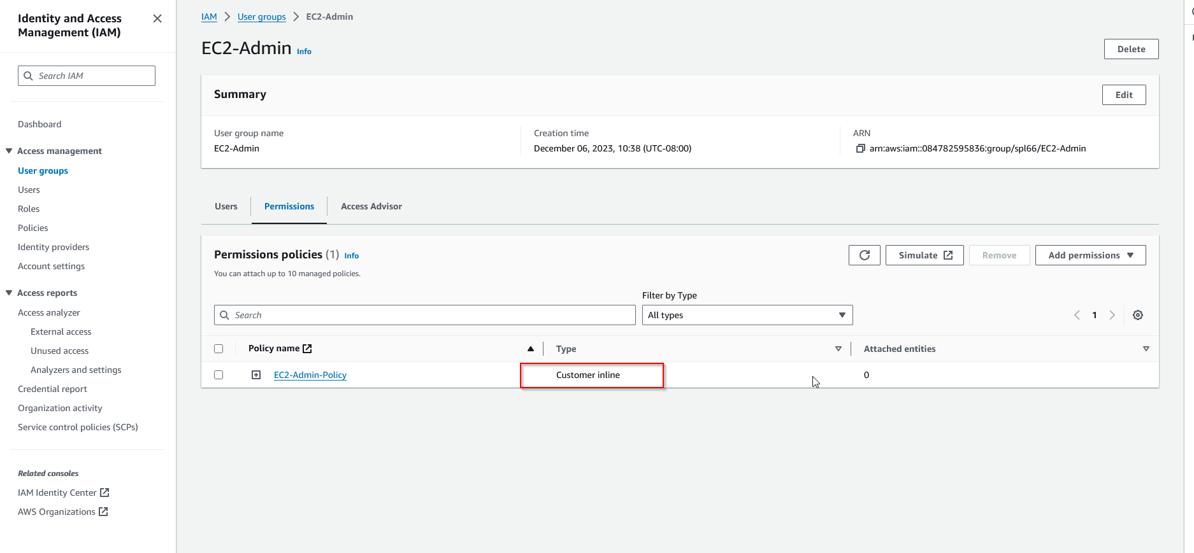

1. In this segment, we will manage IAM. First, add “user-1” to the “S3-Support” group, following the same directions to view the permissions in the previous steps.

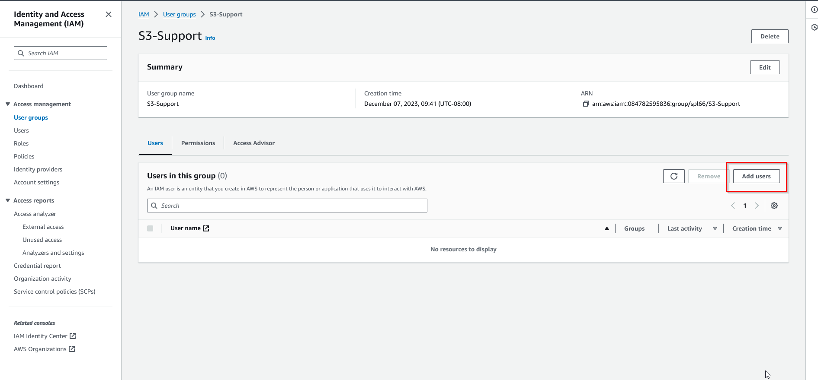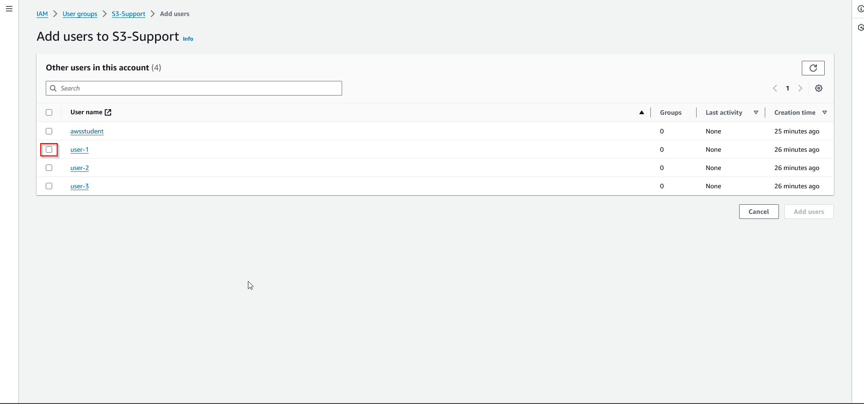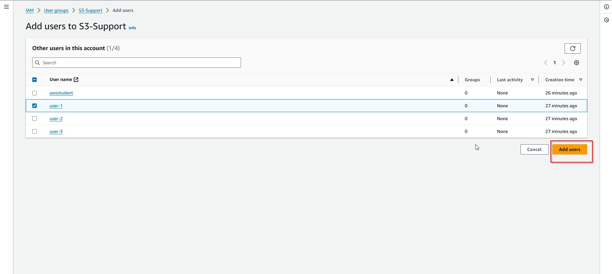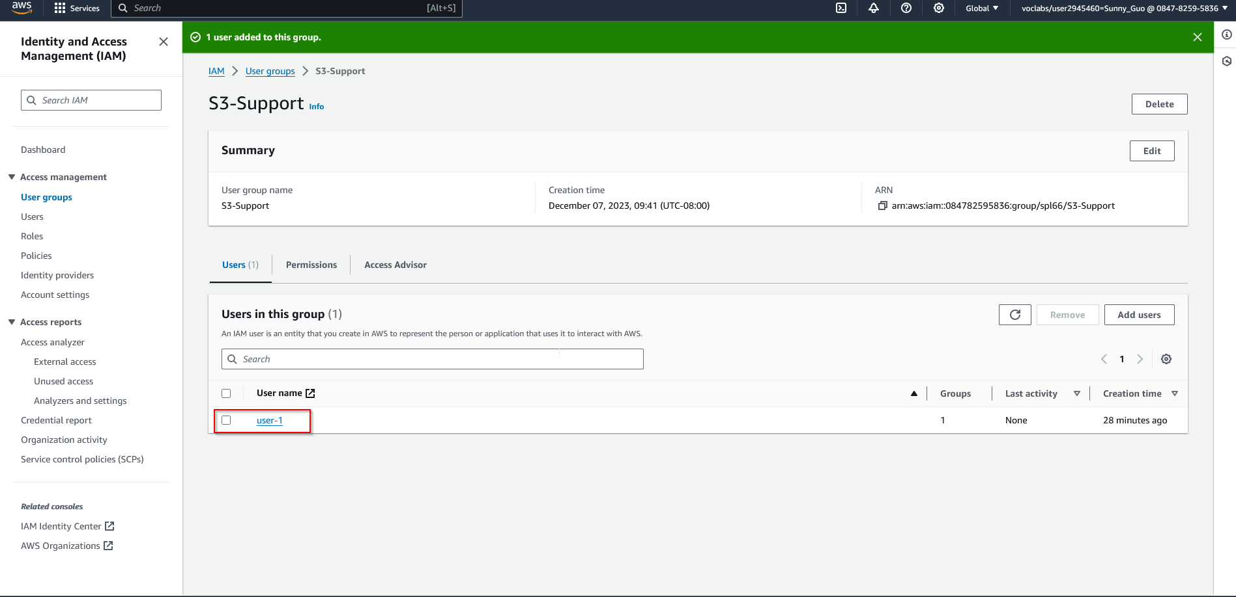

1. Now add “user-2” to the “EC2-Support” group using the same process. 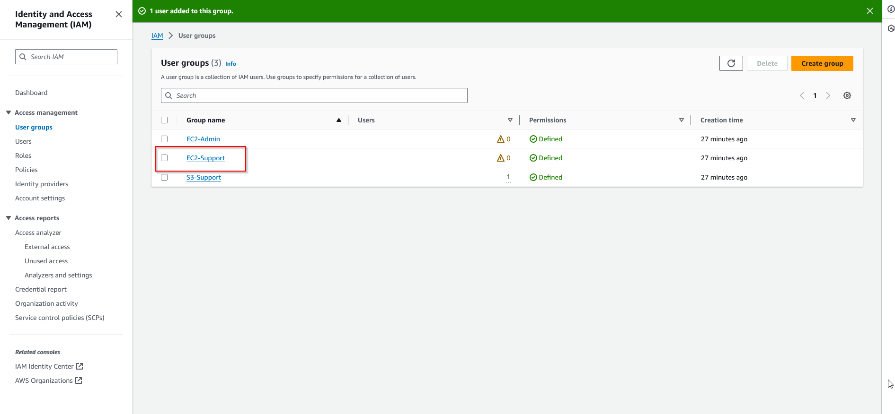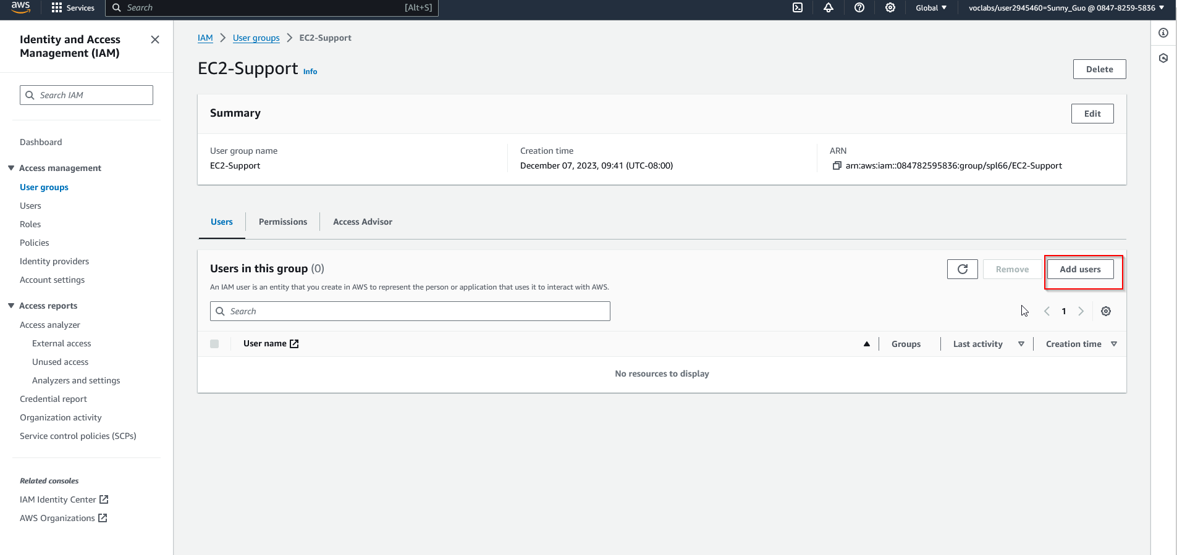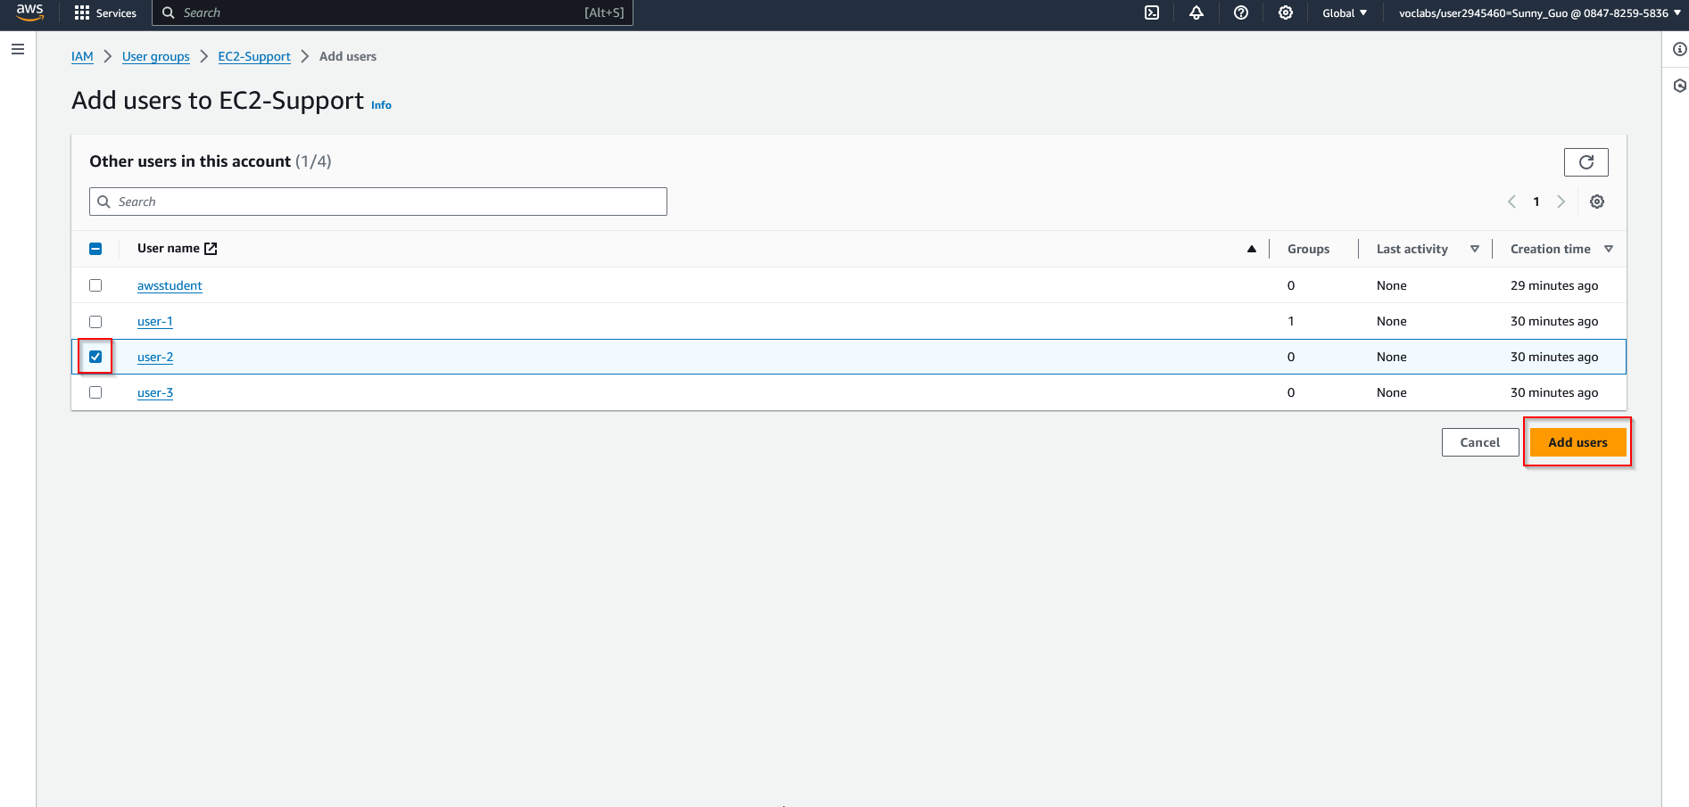
2. Repeat this step for “user-3” and the “EC-2-Admin” group. 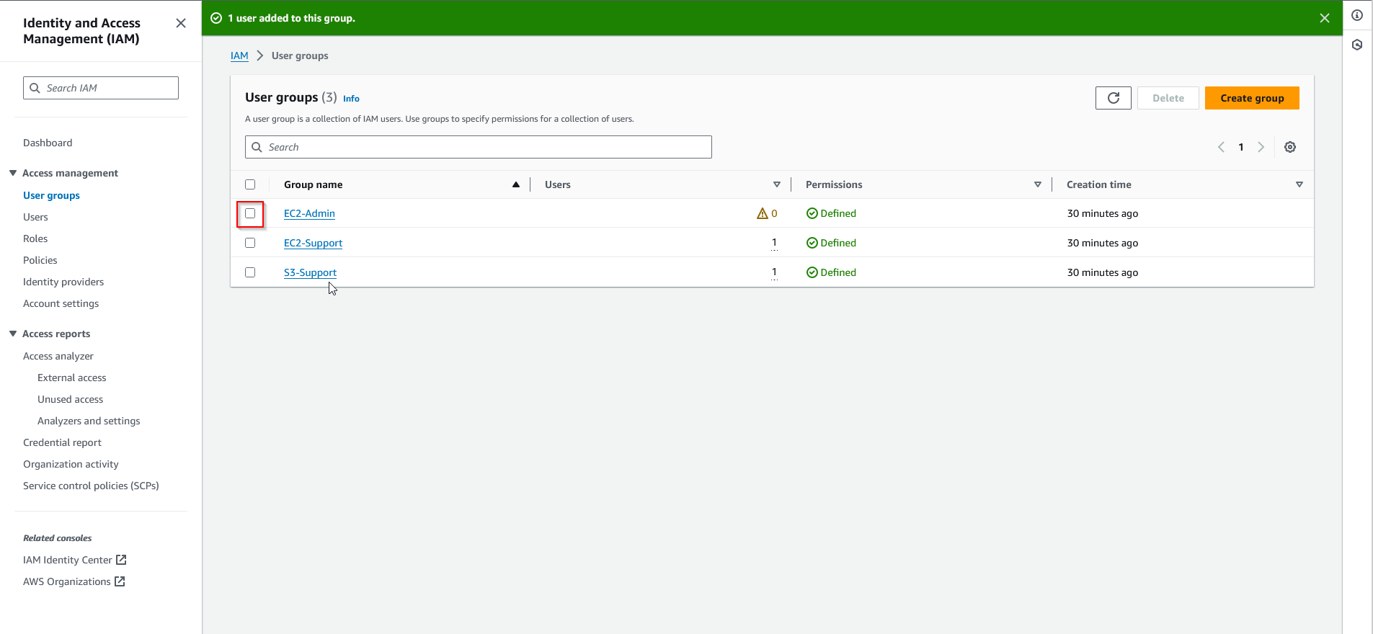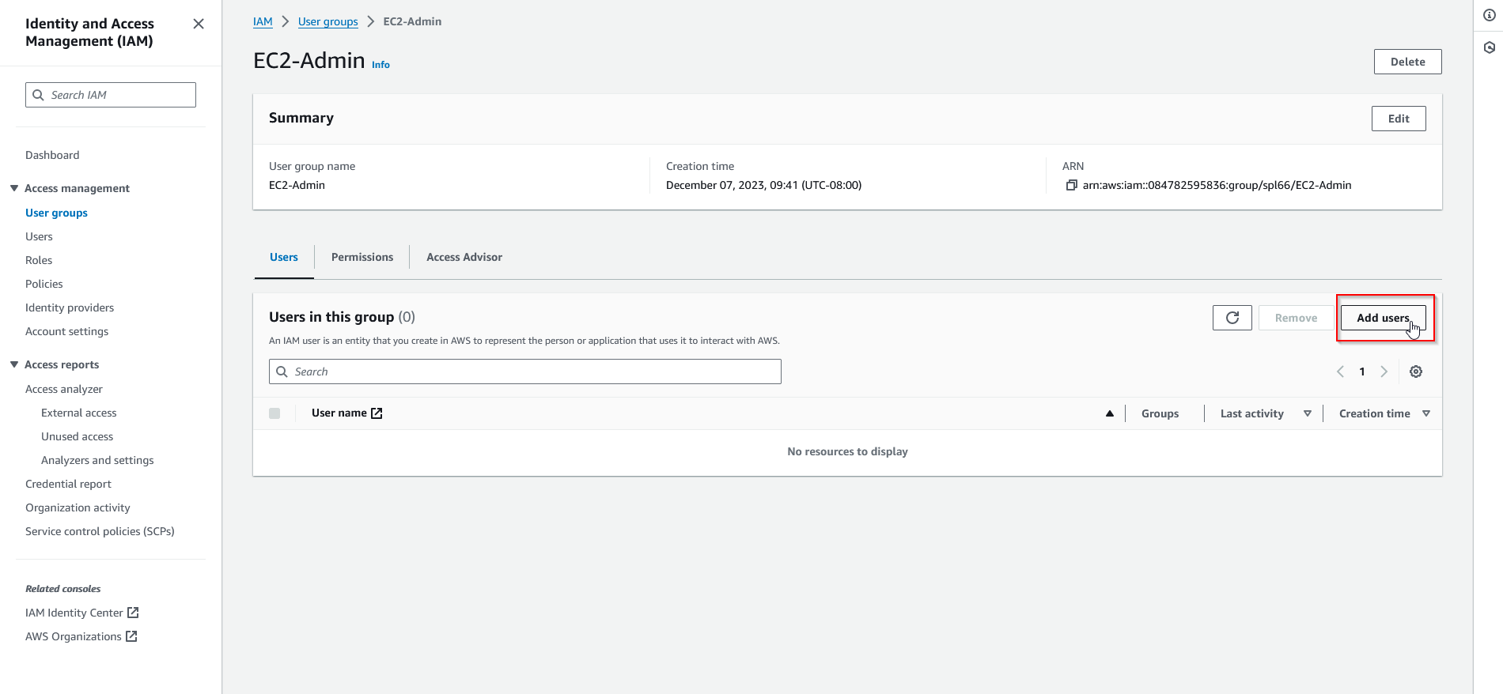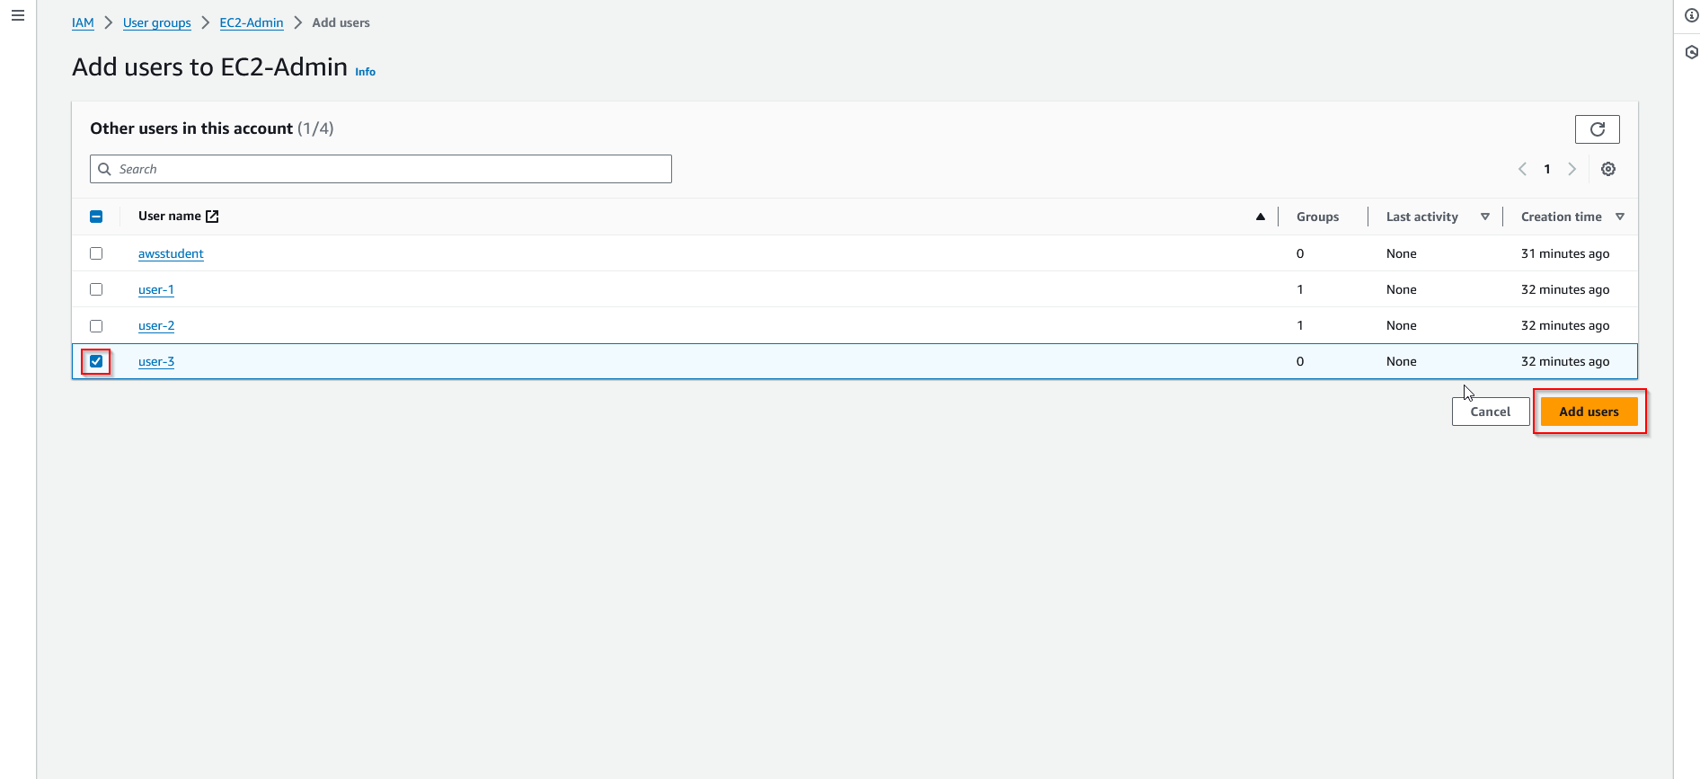
3. Now that the users are added, we can test if the permissions are correctly applied. Navigate to the Dashboard and test each sign-in link with provided credentials.

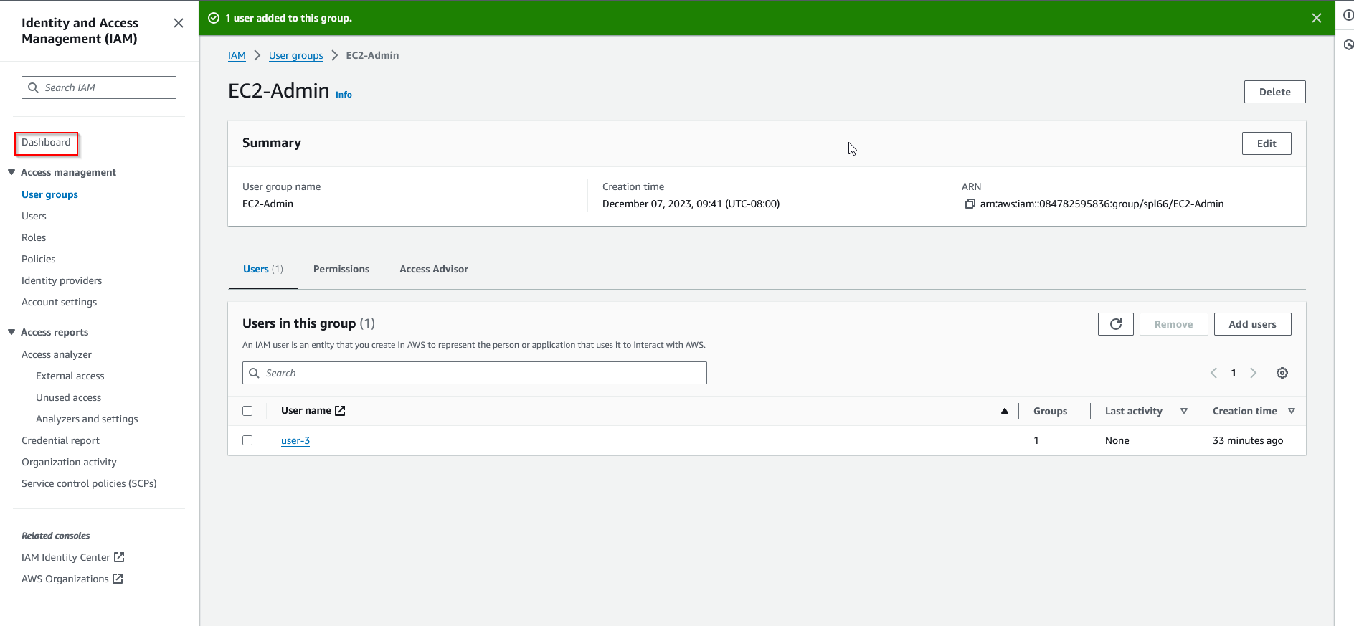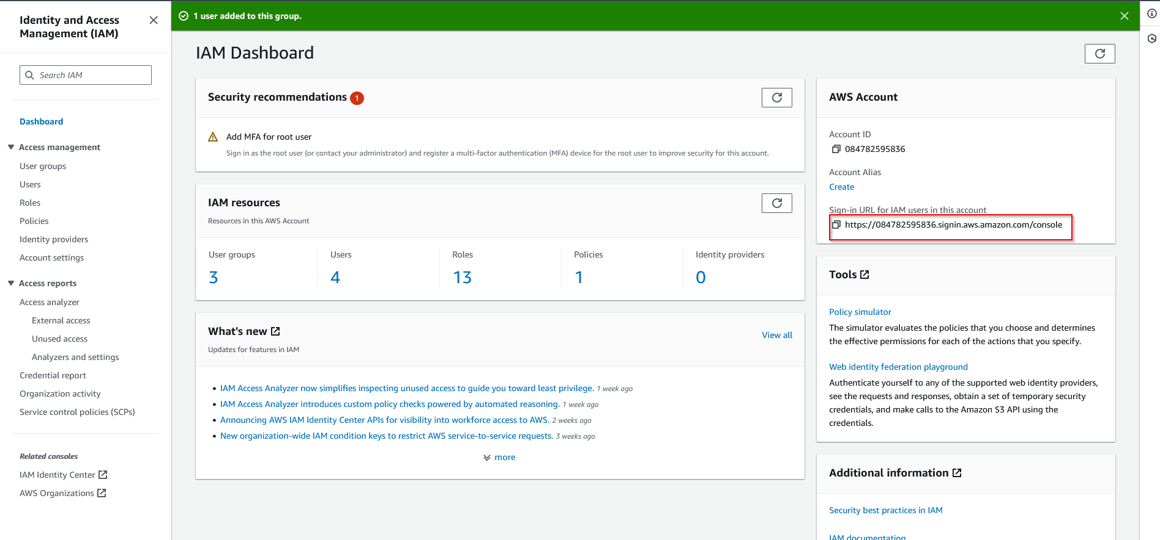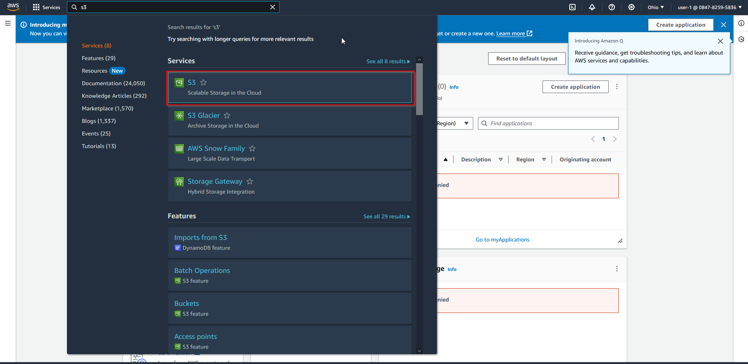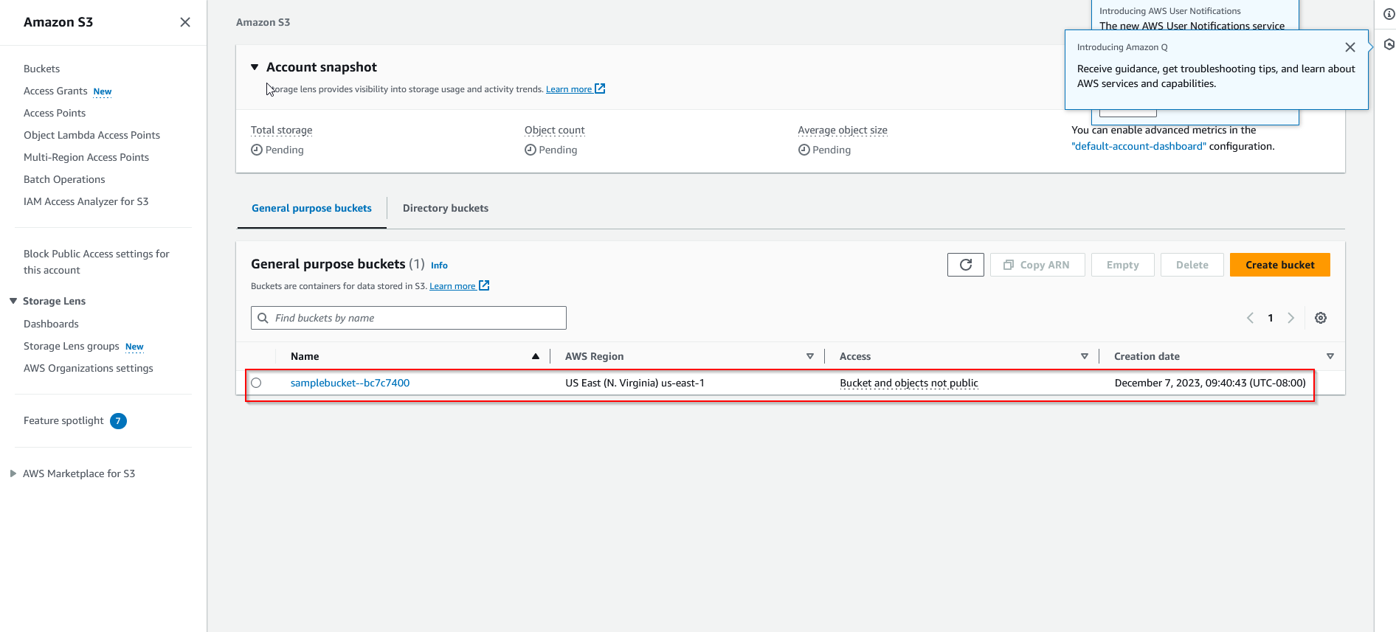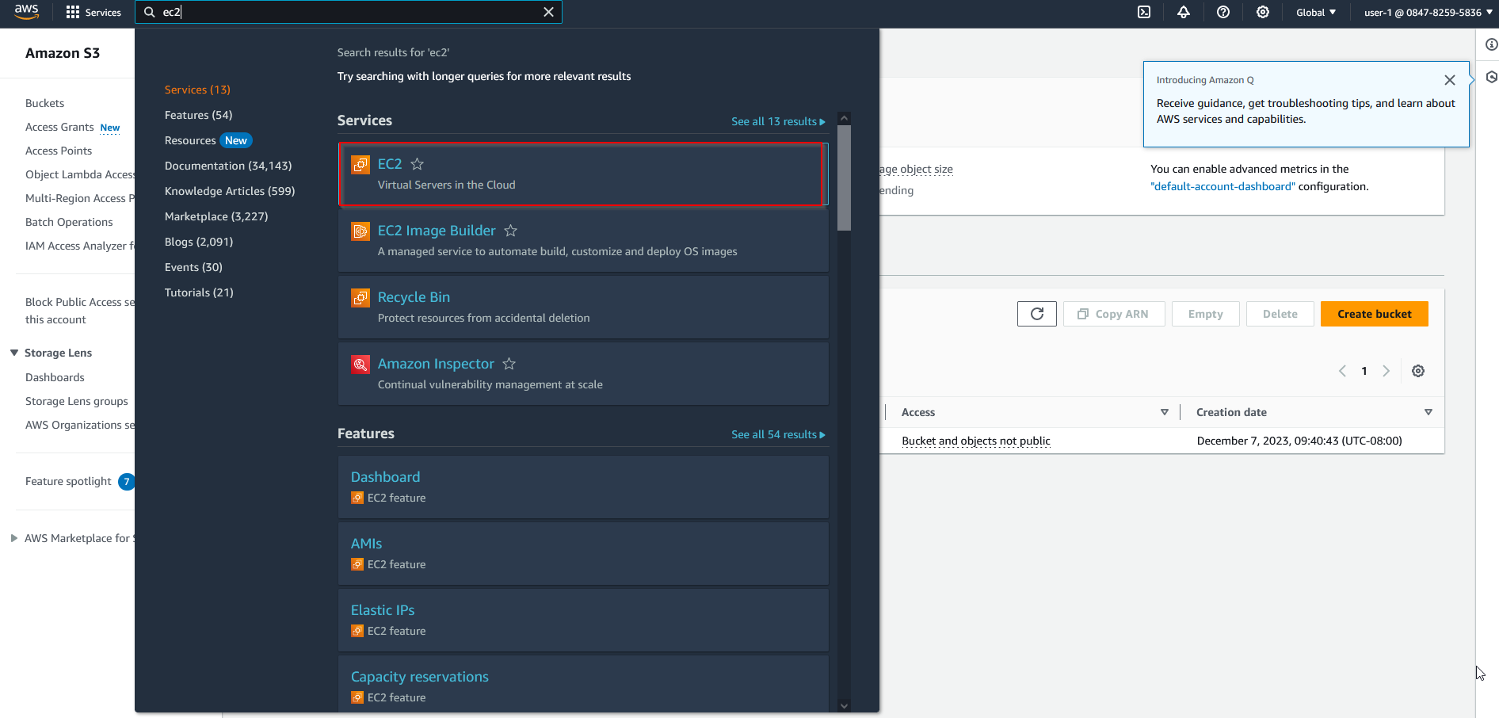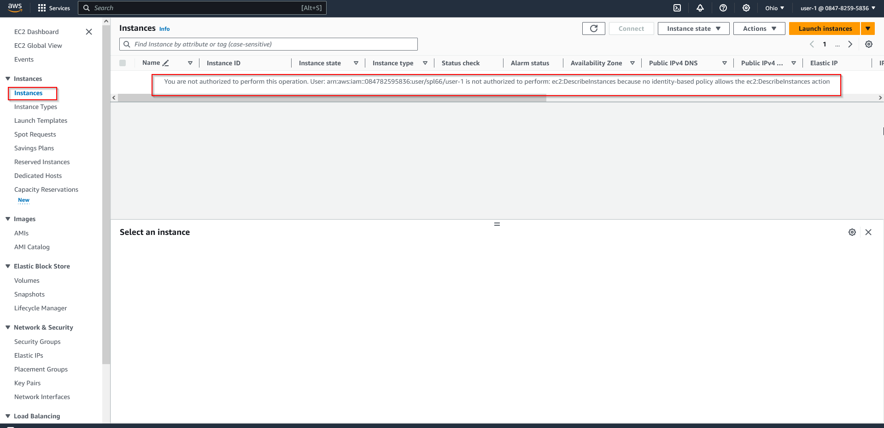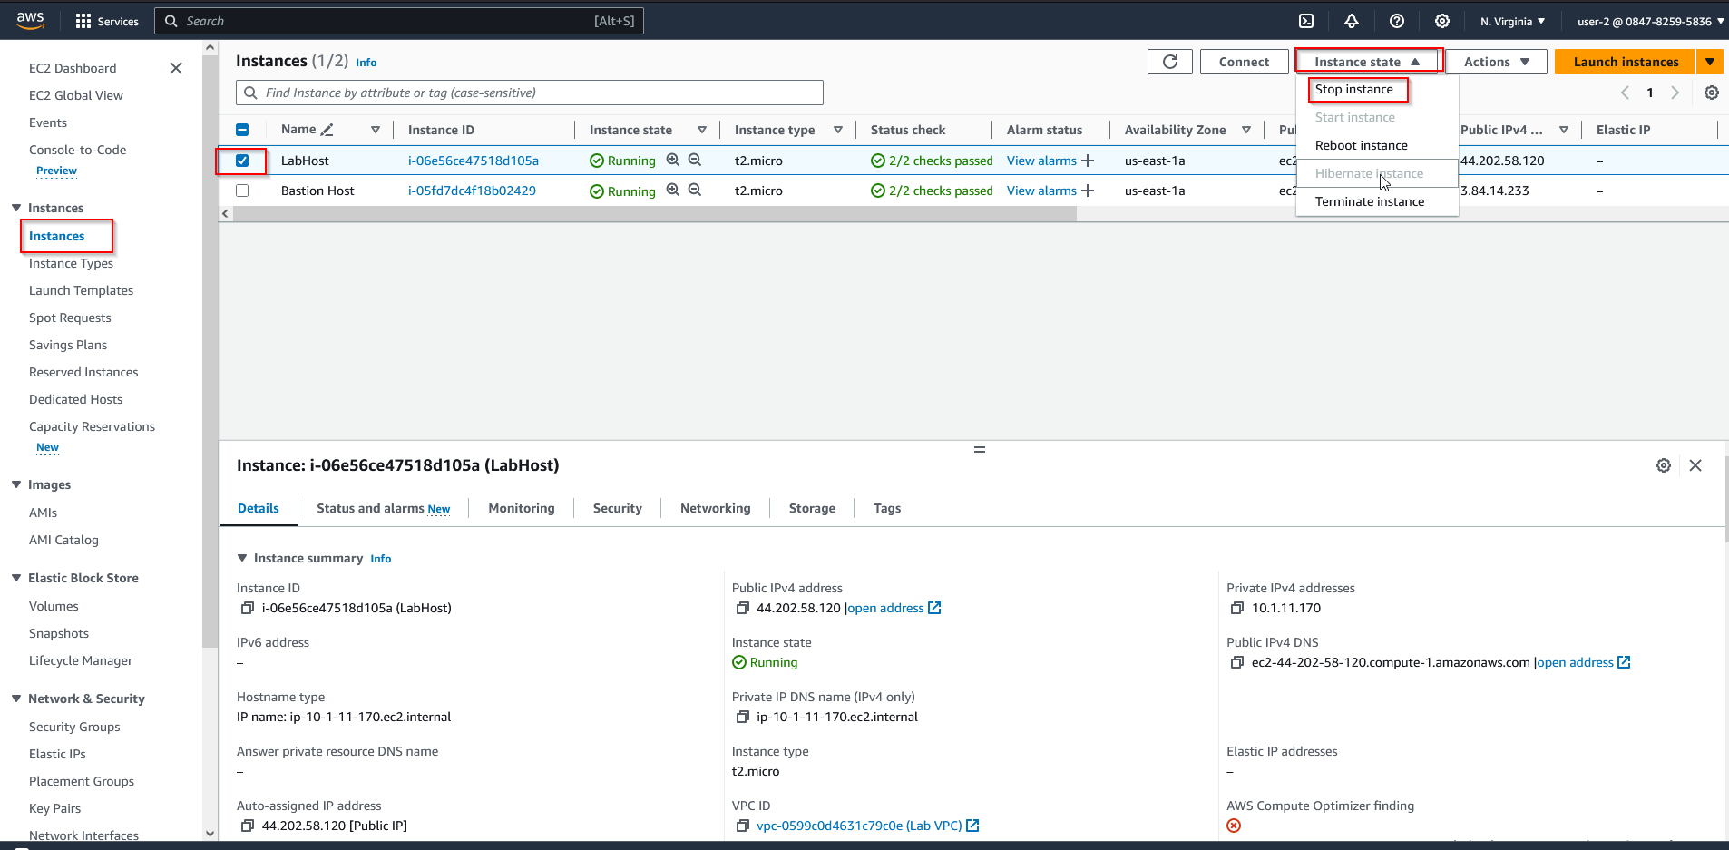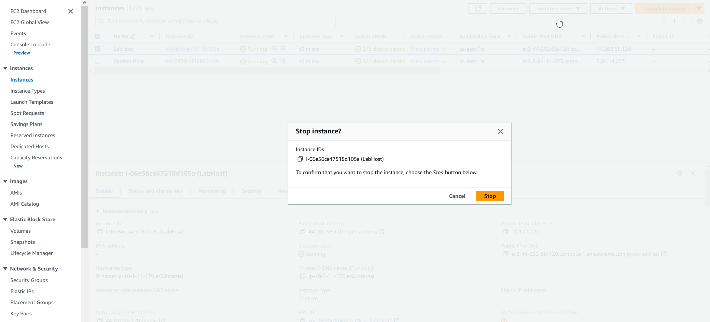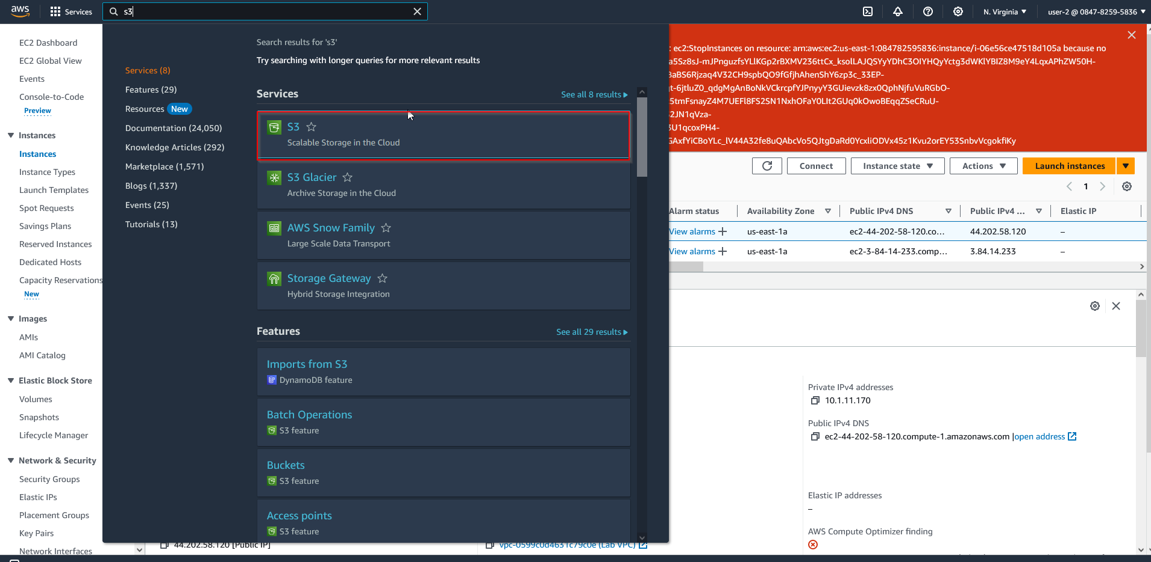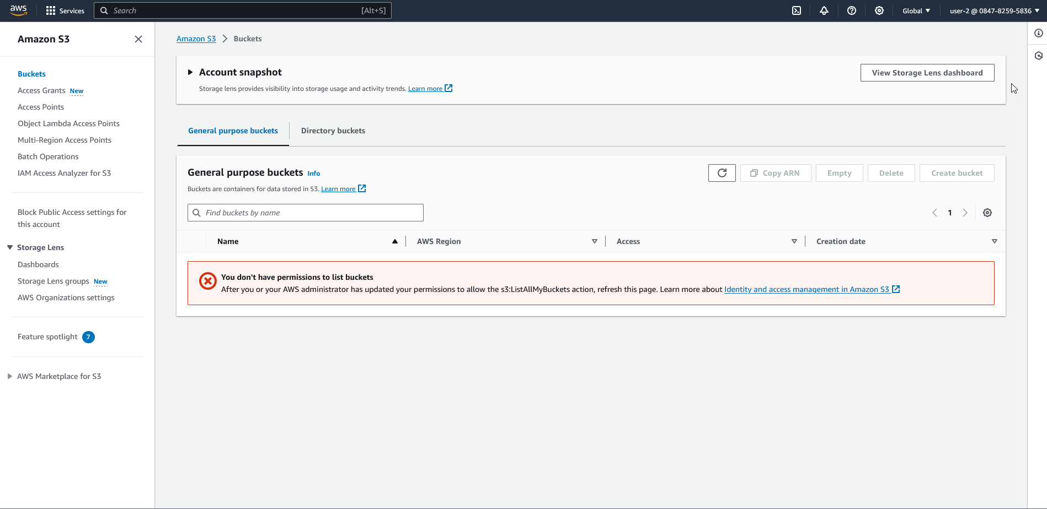

**Lab 2:**

**Network Diagram:**

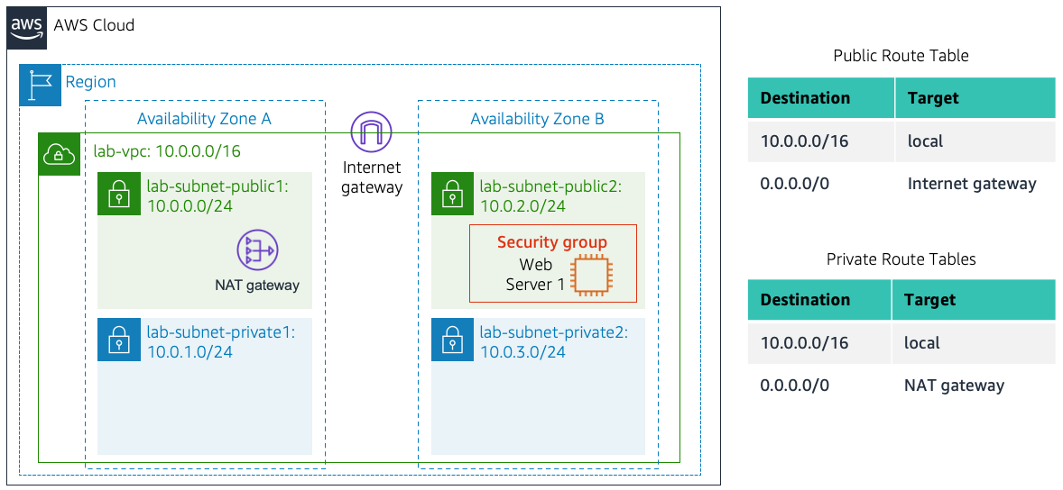

**Lab Instructions:**

This lab utilizes Amazon VPC and EC2 to launch an isolated web server. It covers the basics of creating security groups and instances.

1. Create a VPC by selecting the VPC service and clicking the create VPC button.

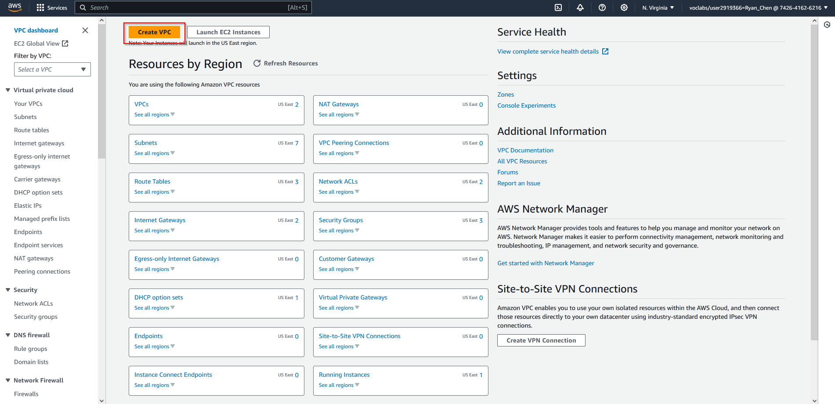

1. Configure VPC settings accordingly, setting availability zones to 1, public and private subnets to 1, and keeping DNS hostnames/DNS resolution enabled.

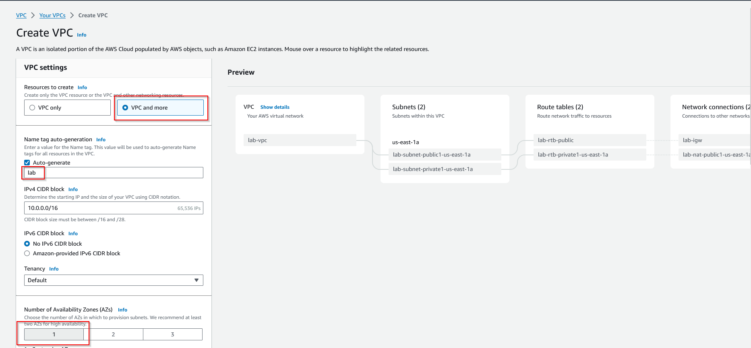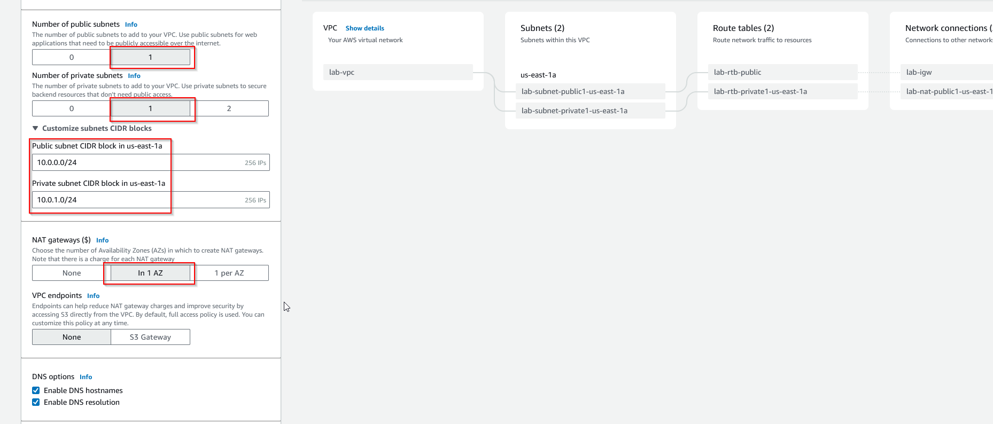

1. Confirm settings and create the VPC.

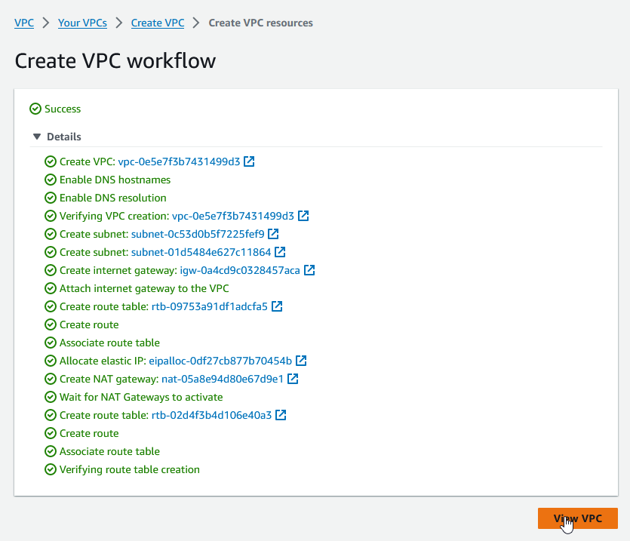

1. View your VPC at the left-hand side.

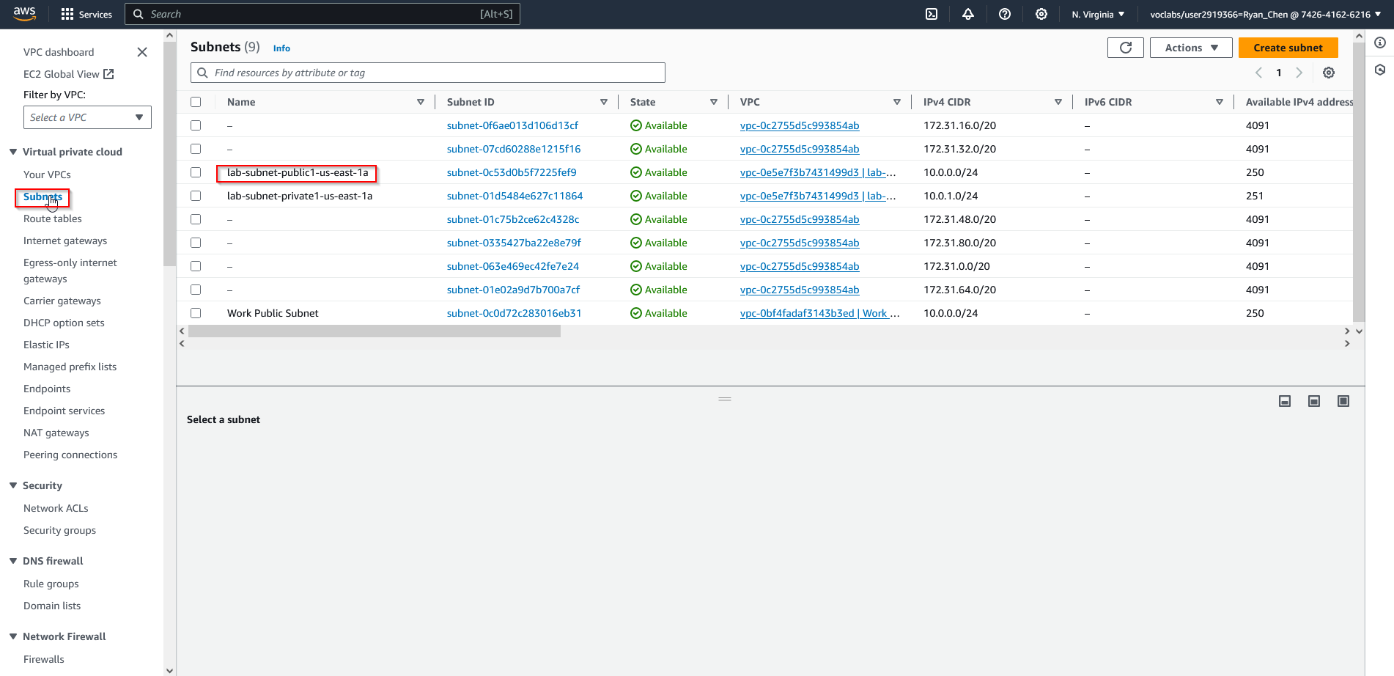

1. Check the routing tables using the same steps.

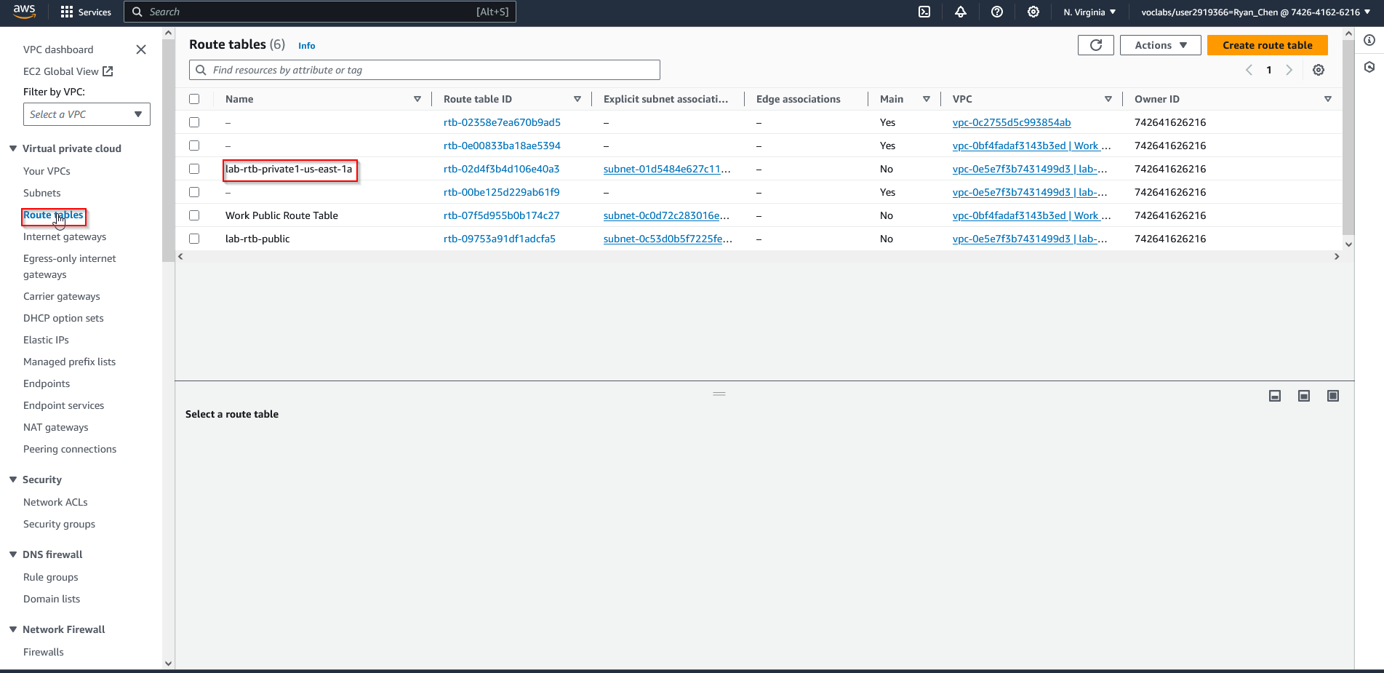

1. Create additional subnets, setting the VPC ID to the one created earlier. Set your subnet name to “lab-subnet-public2” and then create both a public and private subnet.

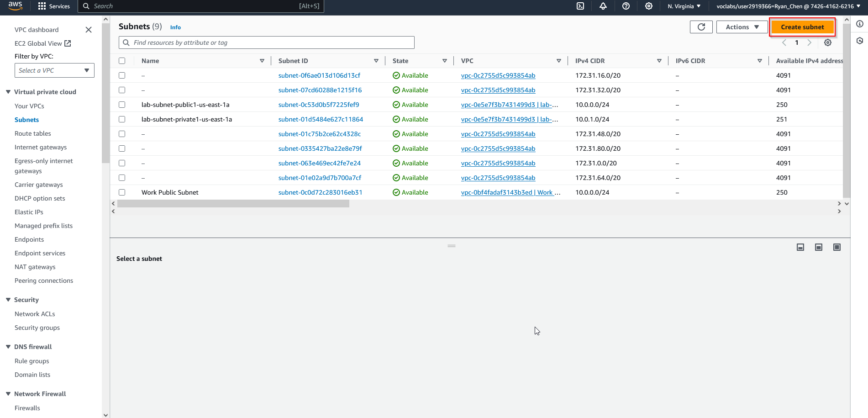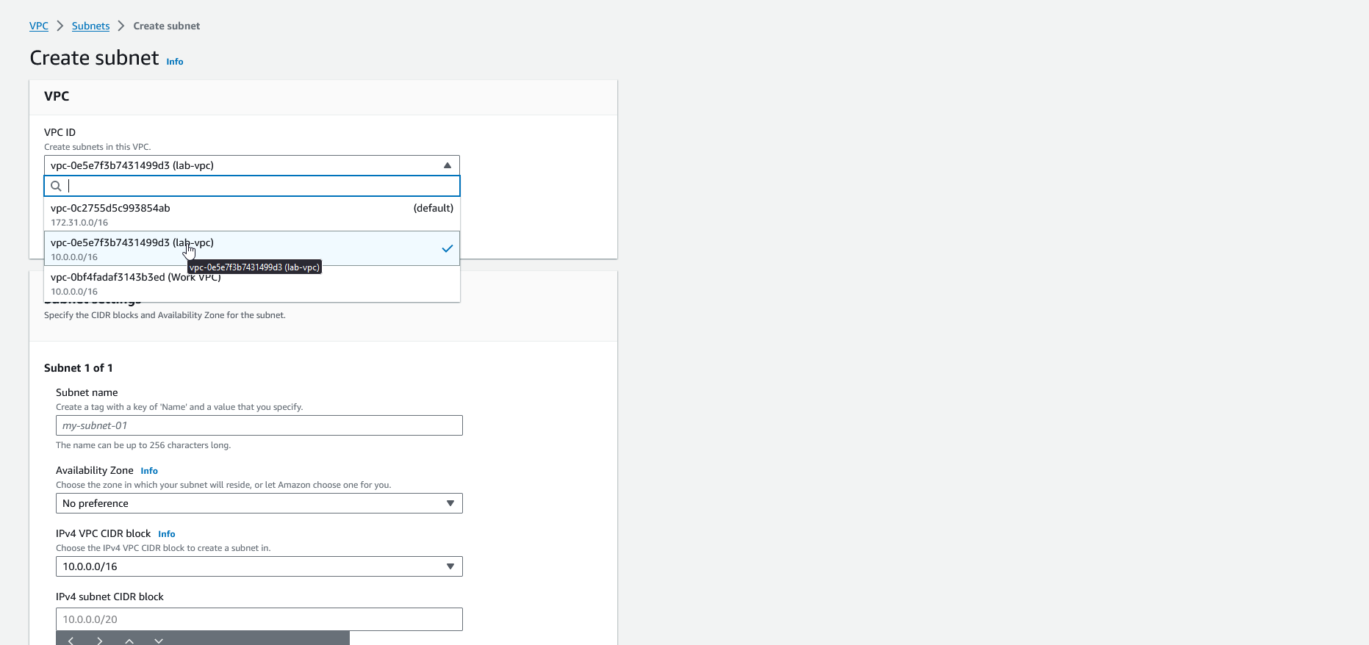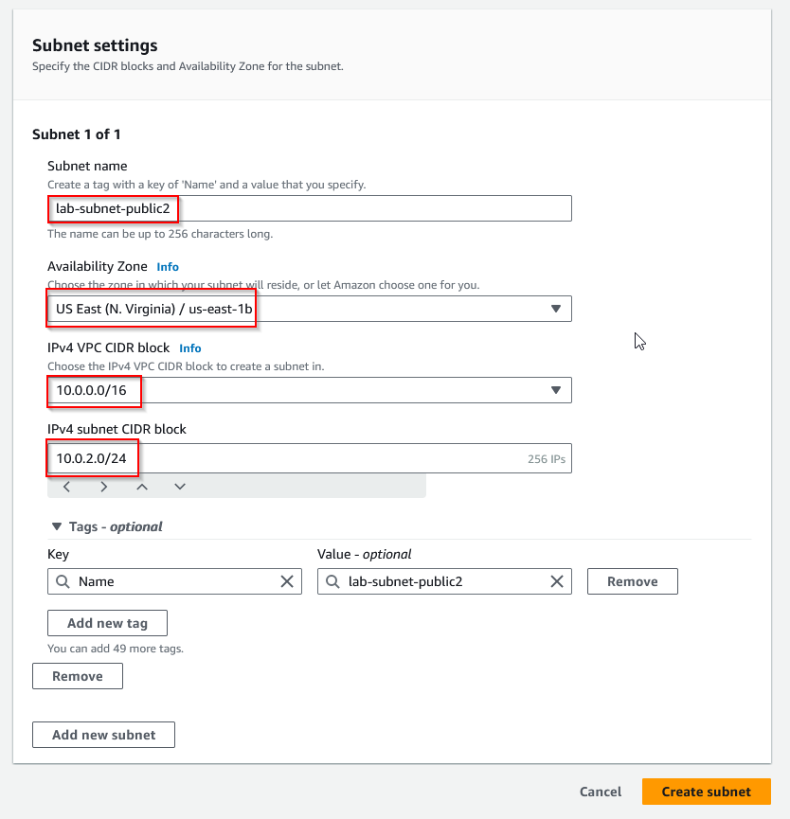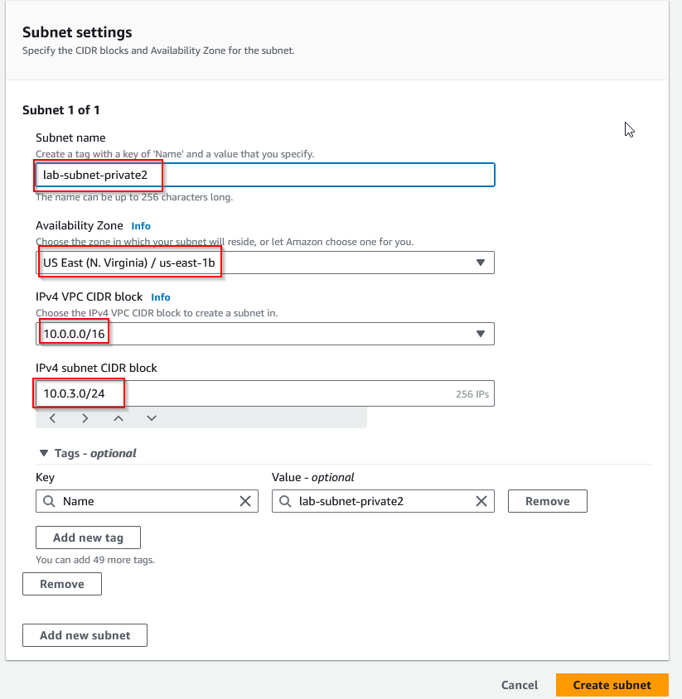

1. On the left, choose route tables and select the “us-east-1a” route table, then observe the destination.

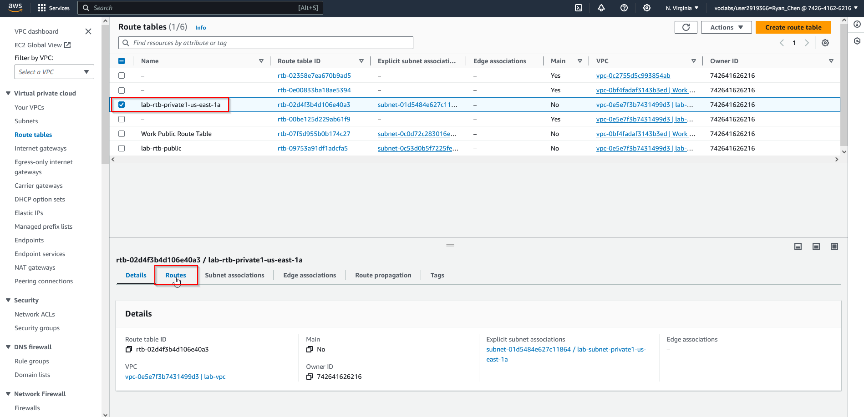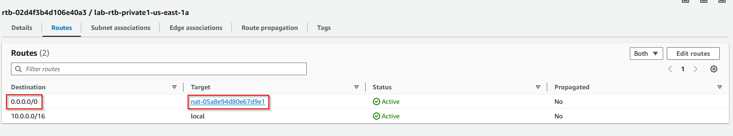

1. Navigate to subnet associations and edit both the private and public subnets. Select both “us-east-1” and “private2”, then save.

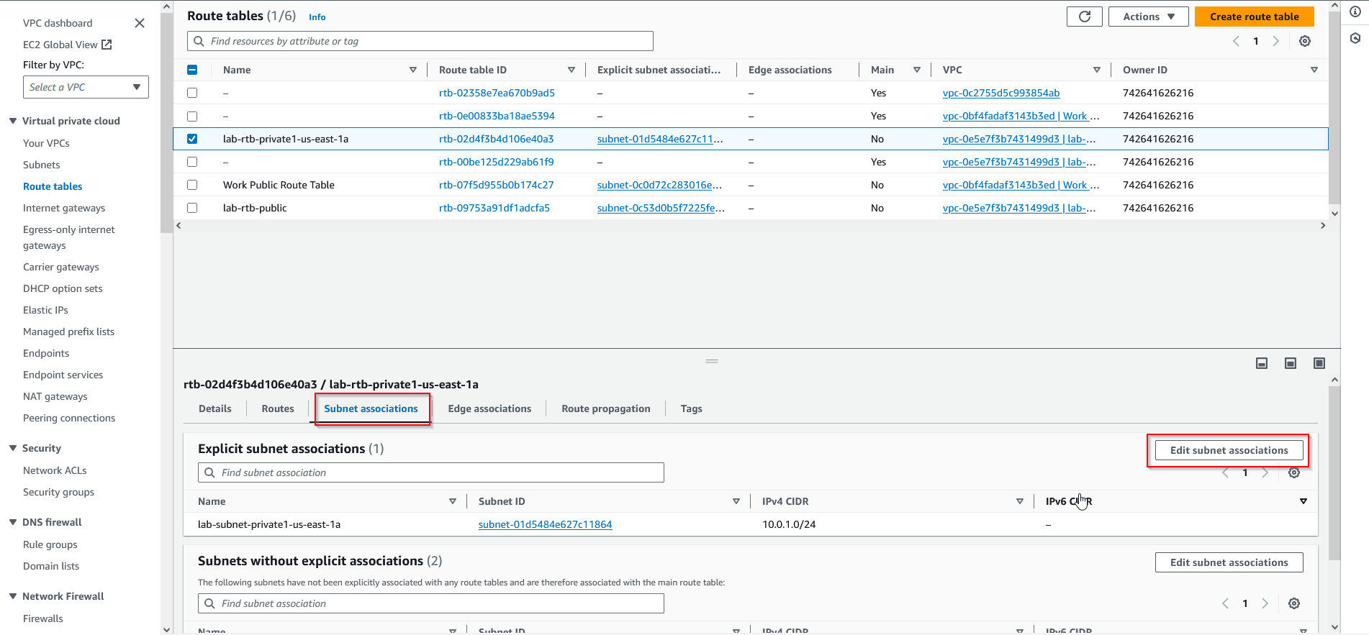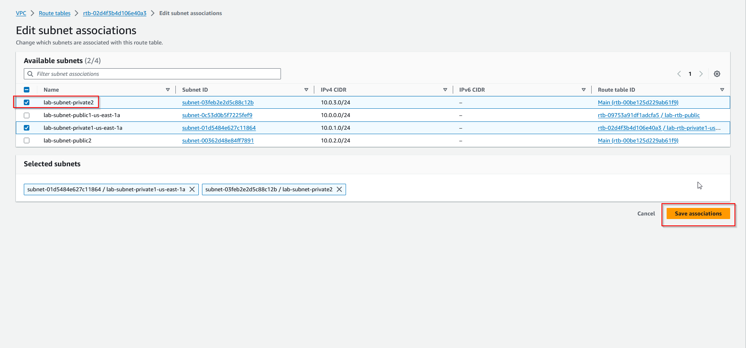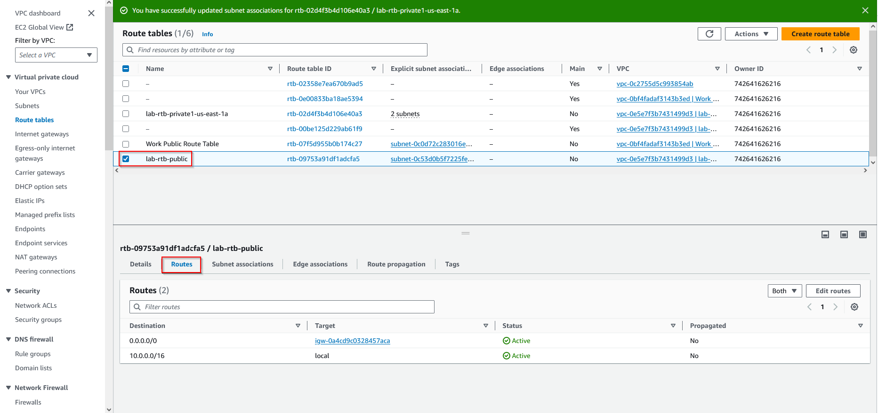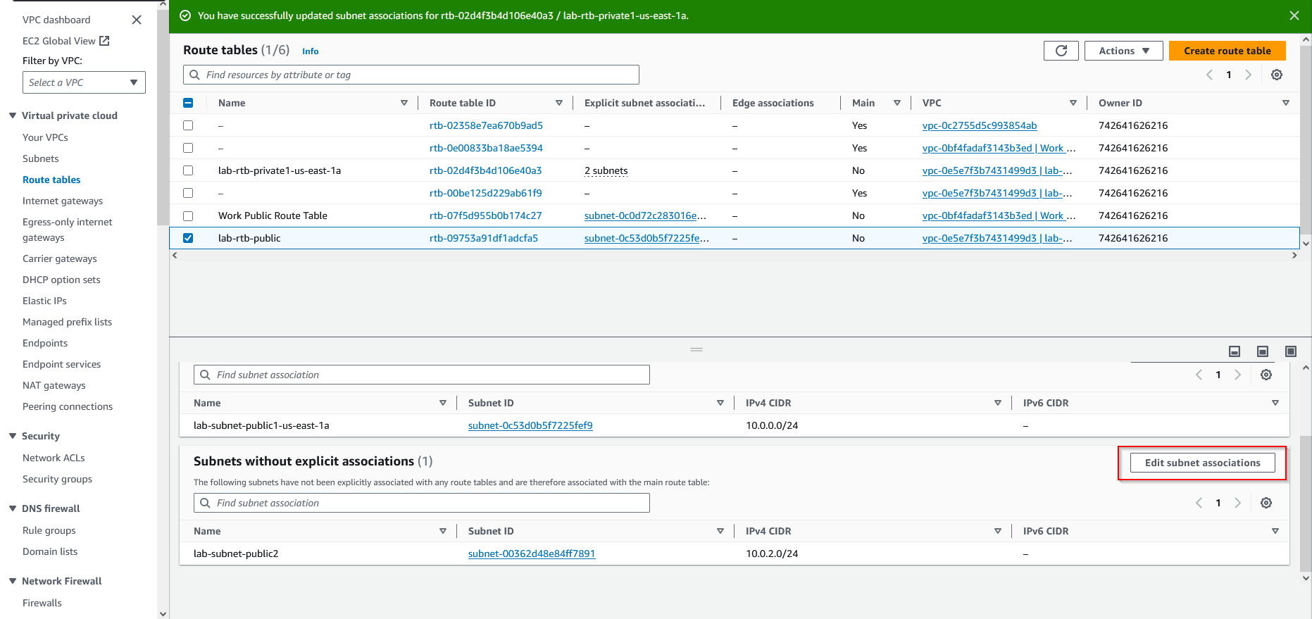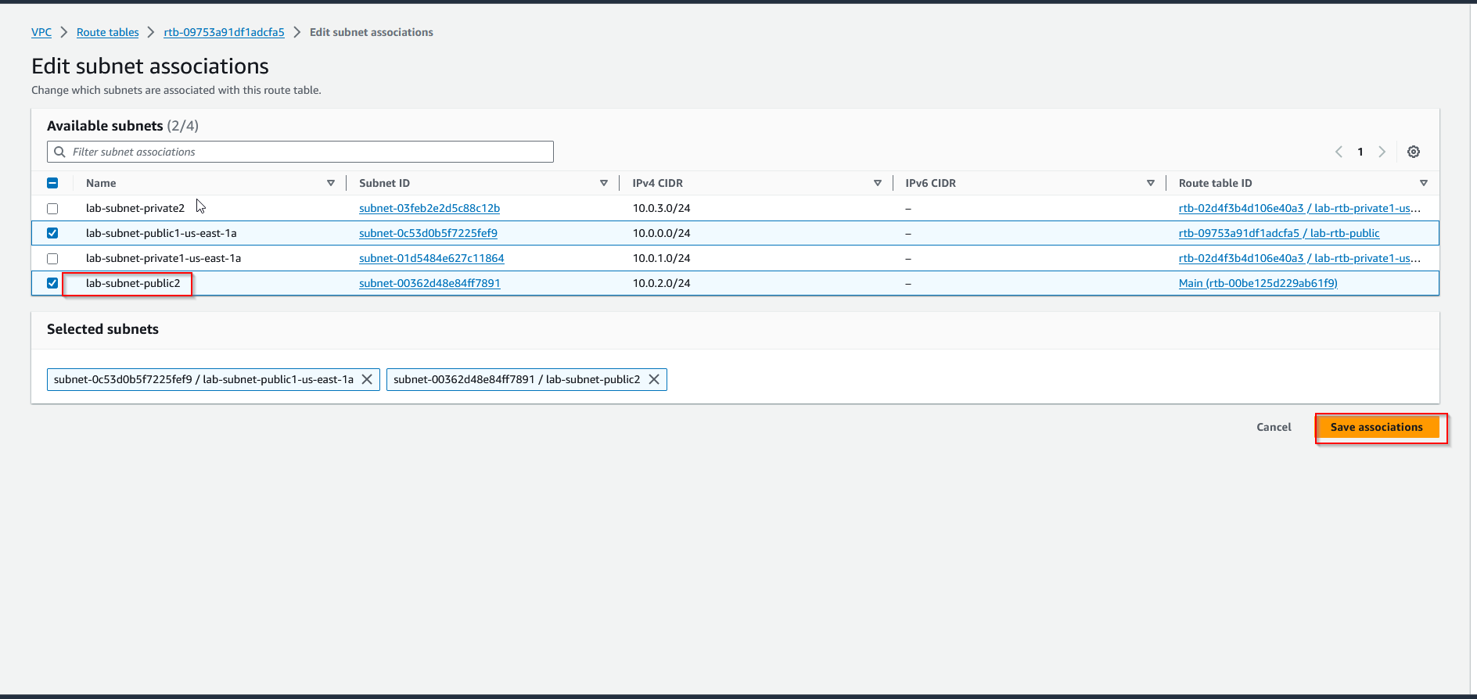

1. Create a VPC security group, with the security name “Web Security Group” and the description as “Enable HTTP access”, then select lab-vpc. 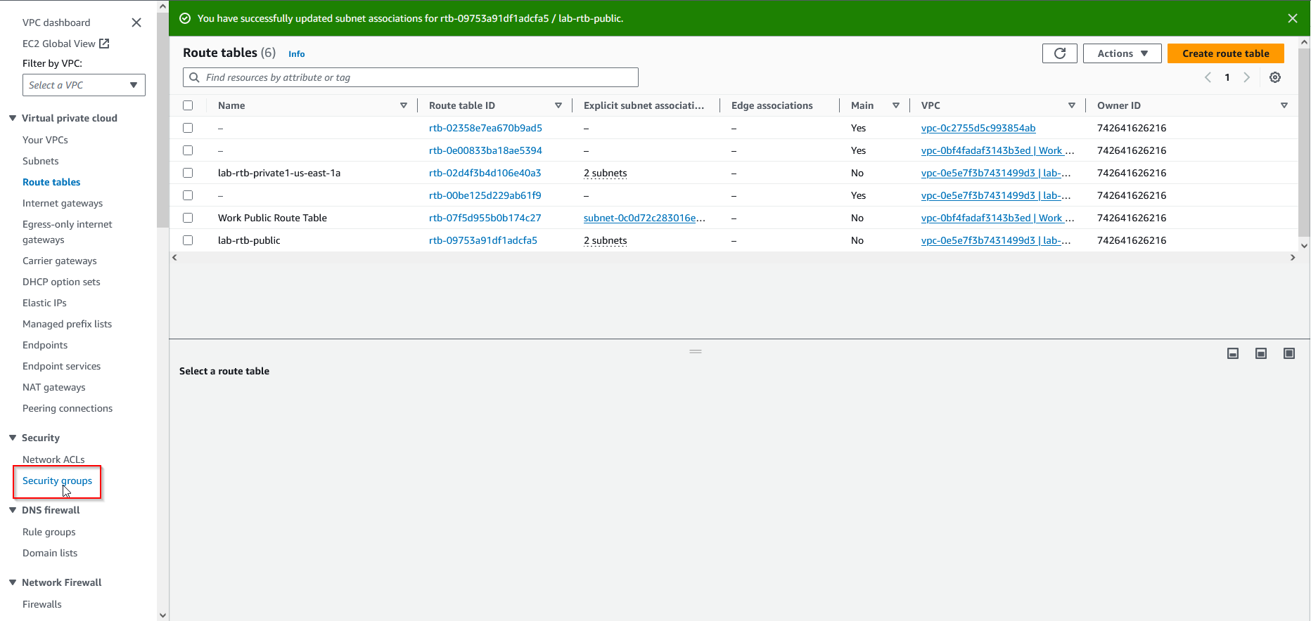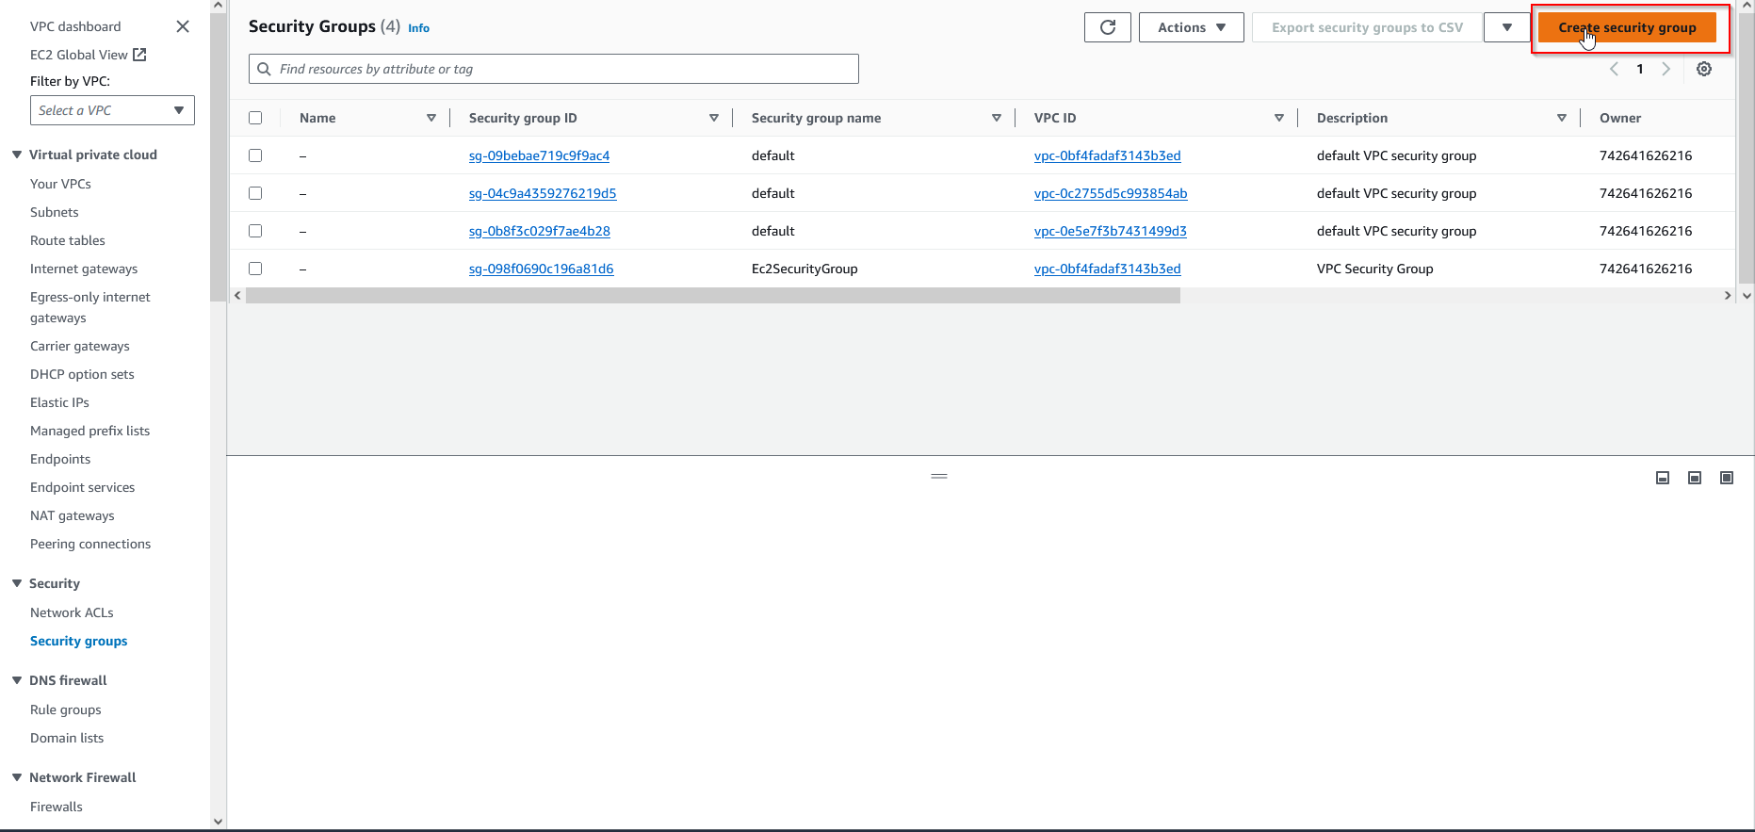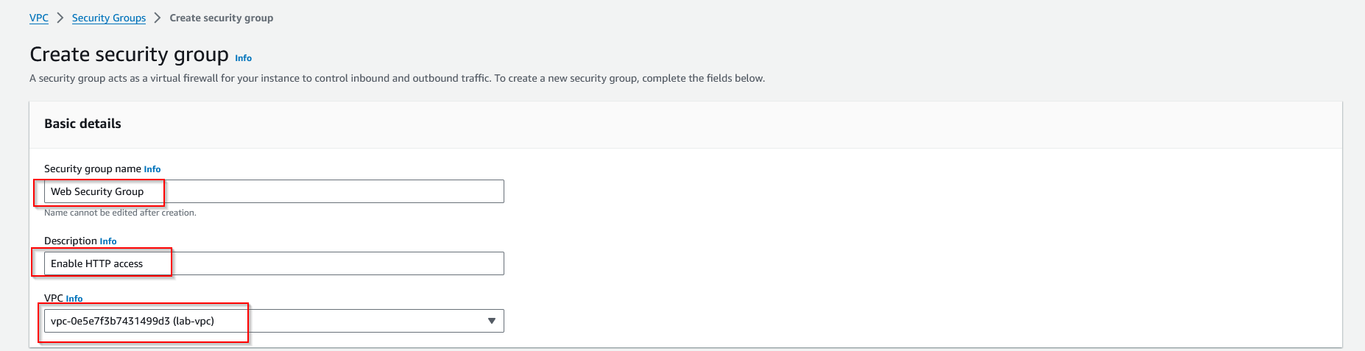
2. Add an inbound rule using HTTP, Anywhere-IPv4, and the description “Permit Web Requests”

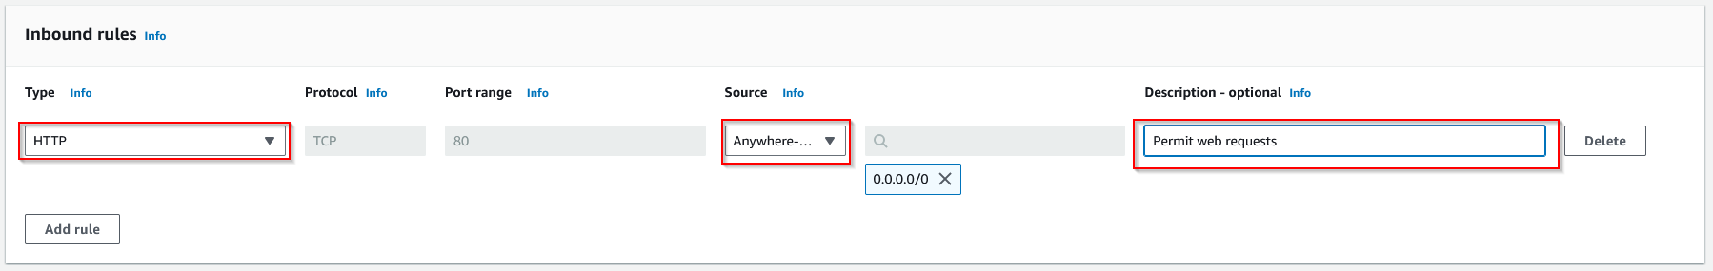

1. Navigate to EC2 and launch a new instance, with the name “Web Server 1”, keeping the default Amazon machine image. Choose “t2.micro” as the instance type, and select “vockey” as the key pair. Then, configure your network settings accordingly.

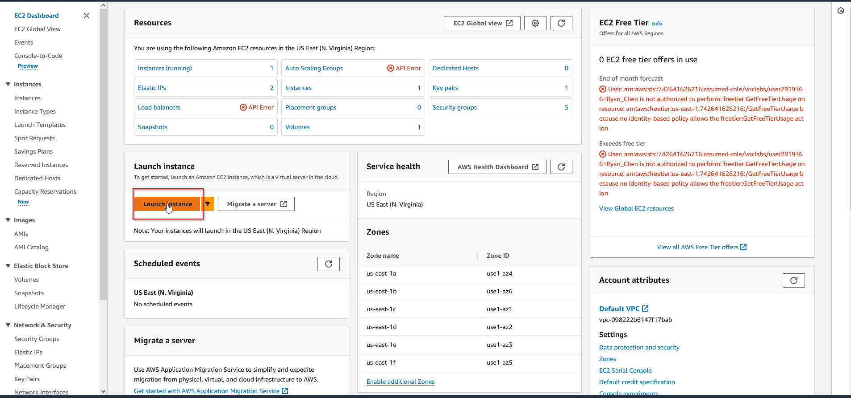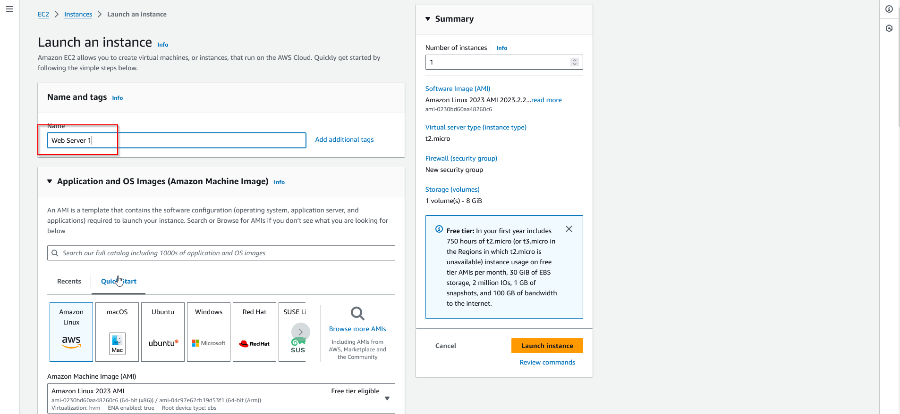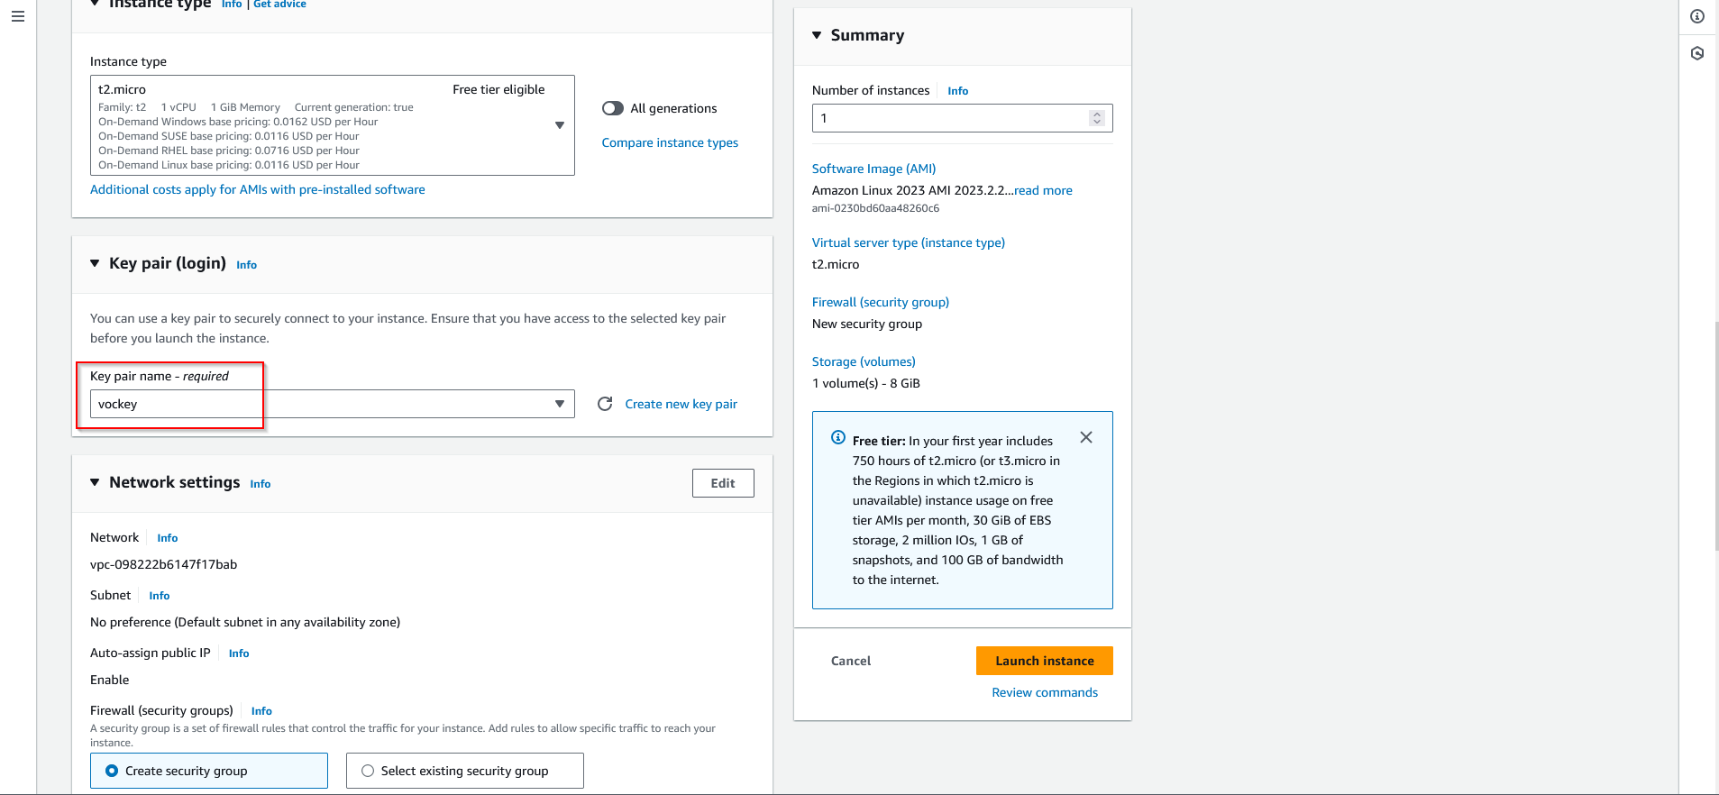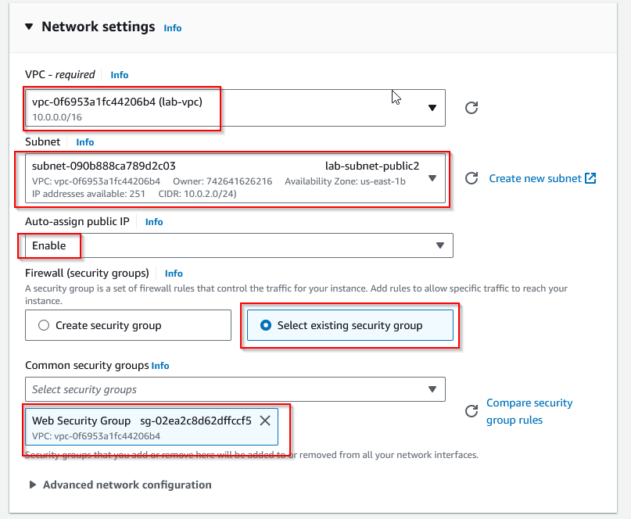

1. In advanced details, paste a script for initiating the web server, then launch the instance.

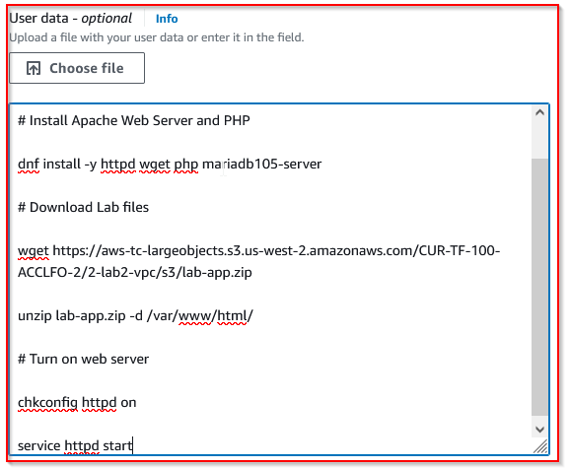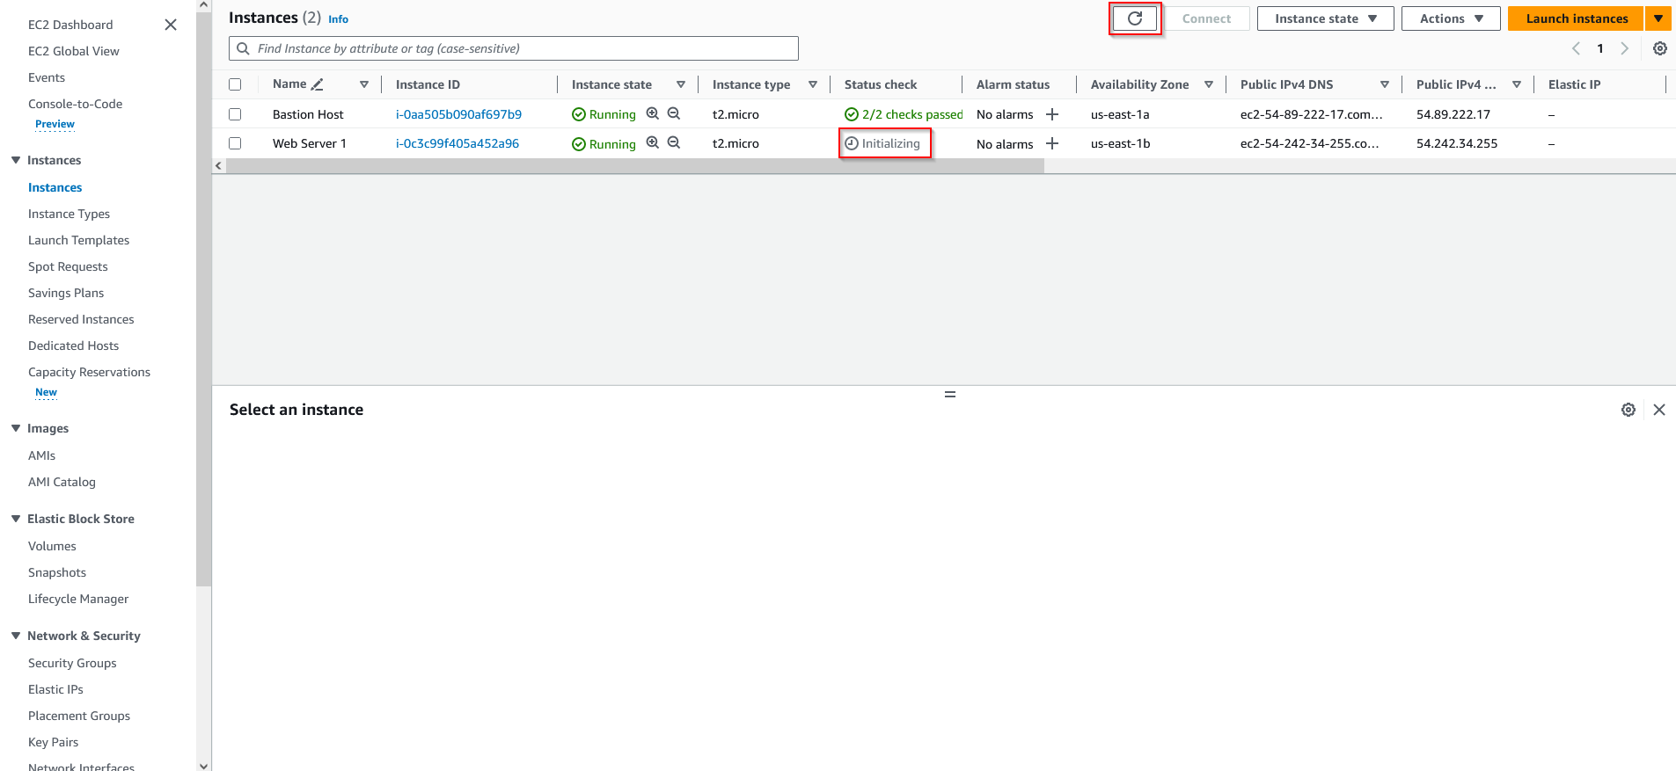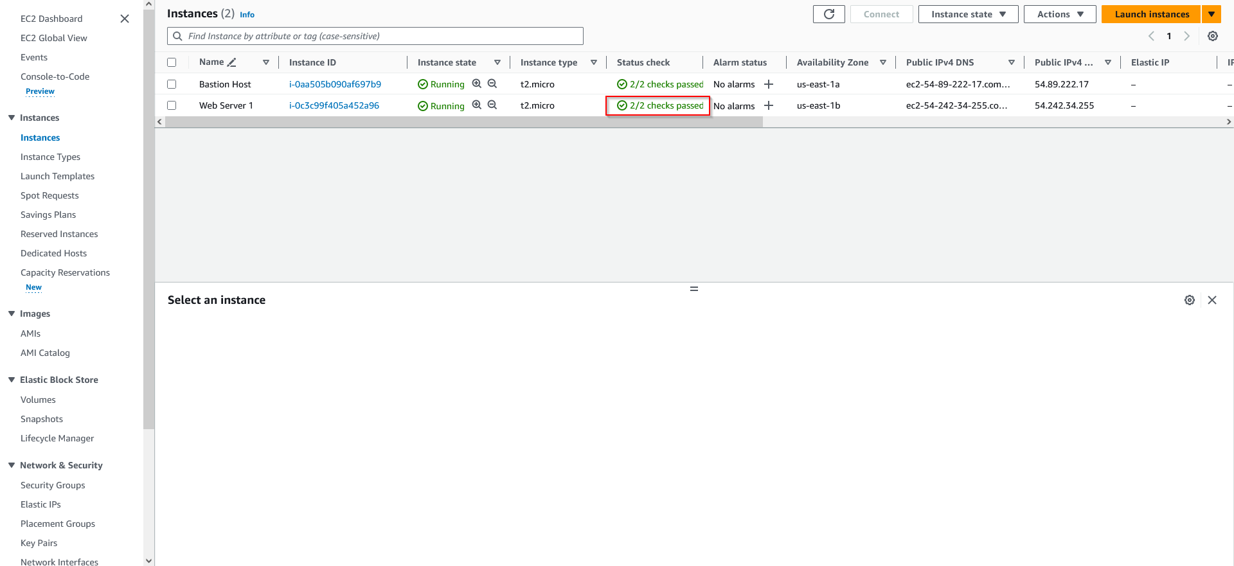

1. Copy and paste the address and view the deployed web server.

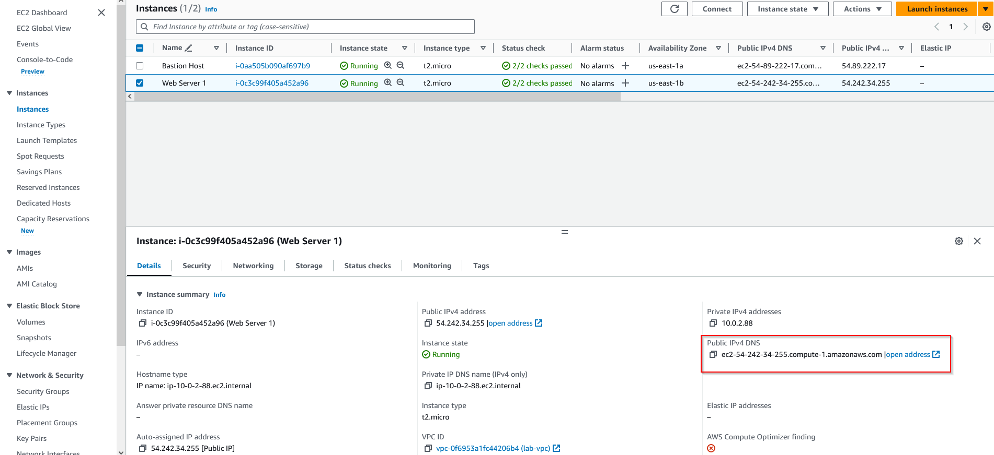

**Lab 3:**

**Network Diagram:**

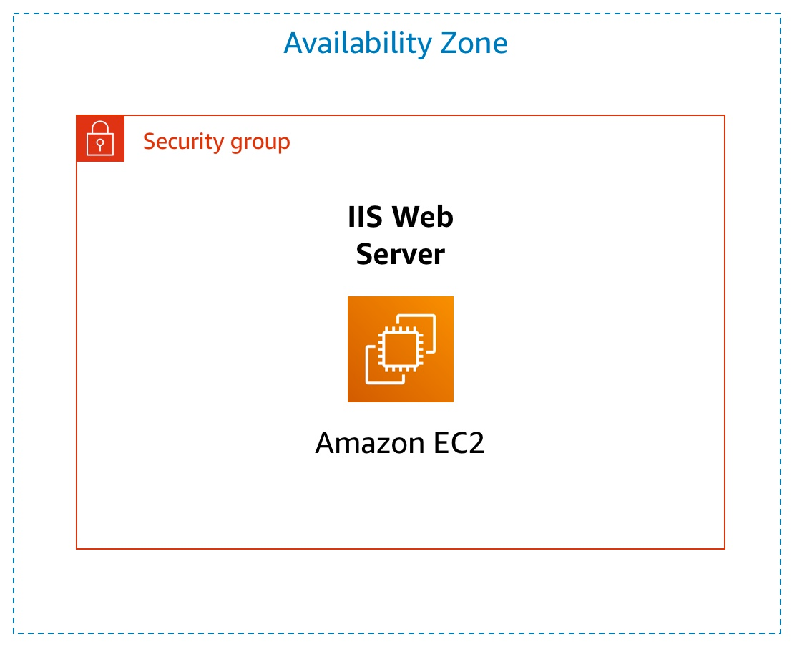

**Lab Instructions:**

This lab dives deeper into the functions and use cases of EC2, with the end goal to deploy a scalable web server.

1. Navigate to EC2 in the Services panel and launch an instance.

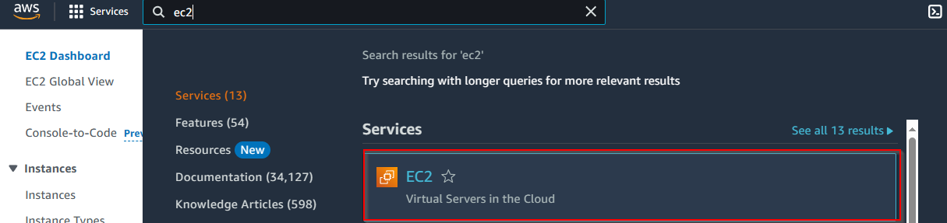

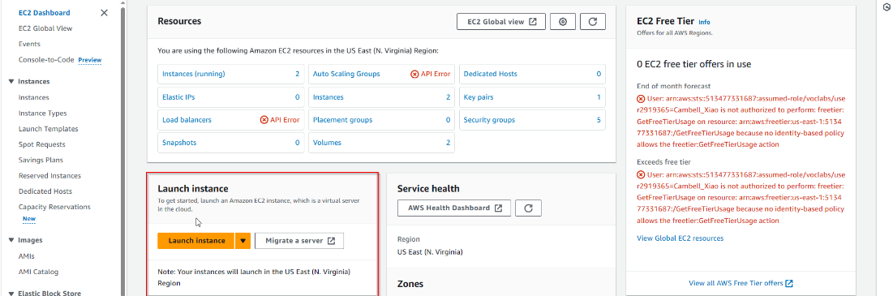

1. Name the instance and select the Amazon machine image, select “t2.micro”, and “vockey”. Configure network settings accordingly based on existing VPC and subnets. For storage, use the default settings.

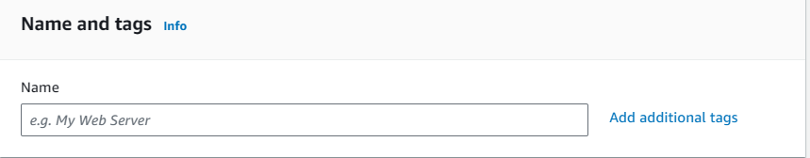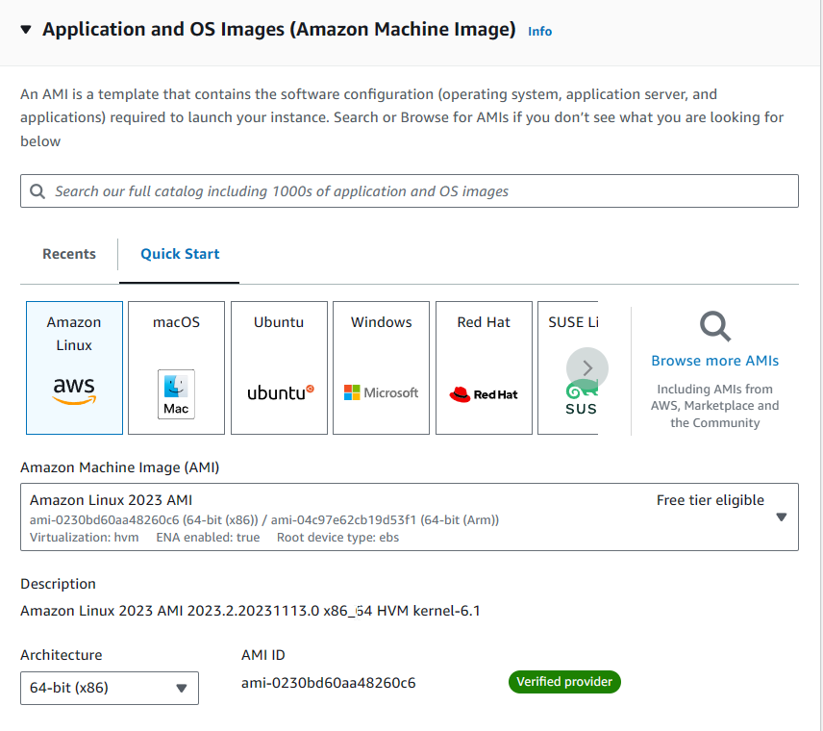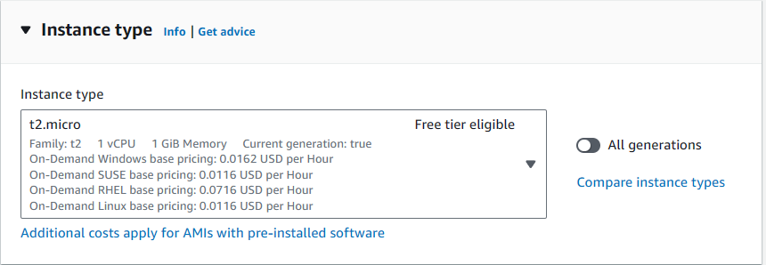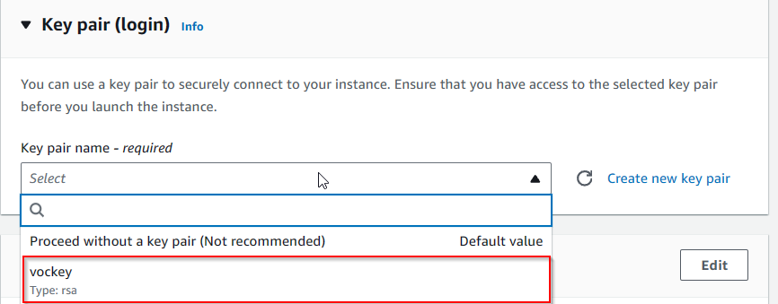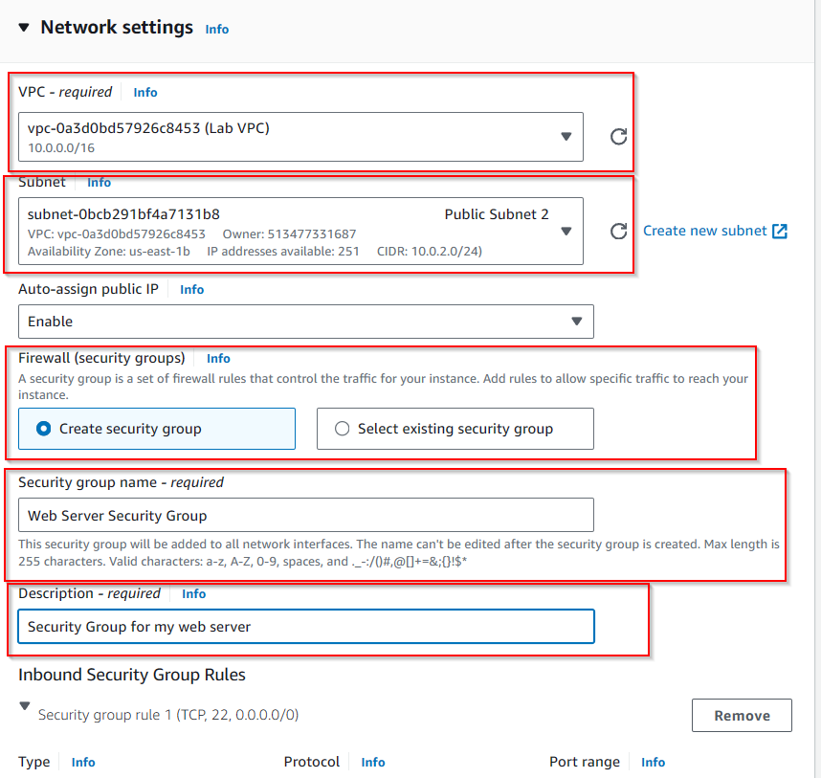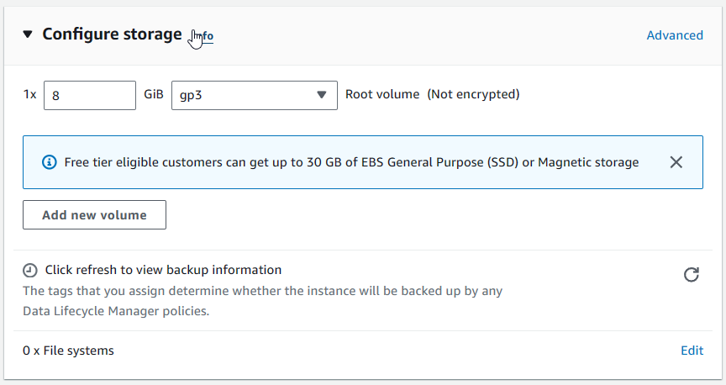

1. In advanced settings, enable termination protection. This prevents the instance from being removed from either API or CLI.

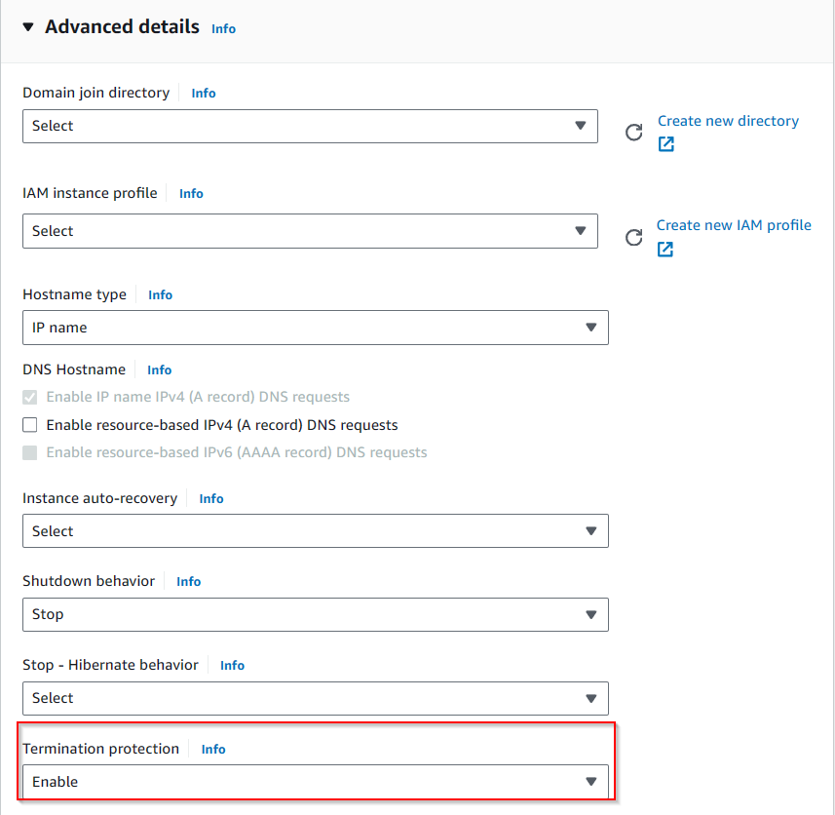

1. Enter in starter configuration commands to run. For this lab, the commands are preconfigured to create a basic web server.



1. Launch the instance.

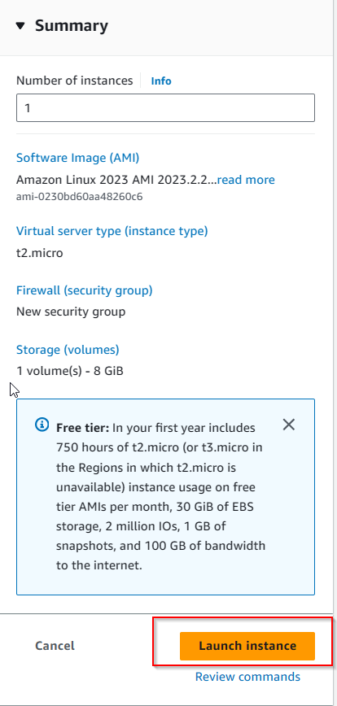

1. Check your instance status and make sure that it passes all checks.

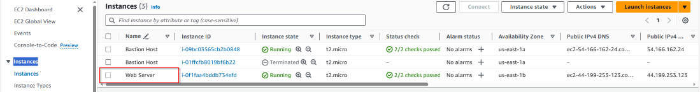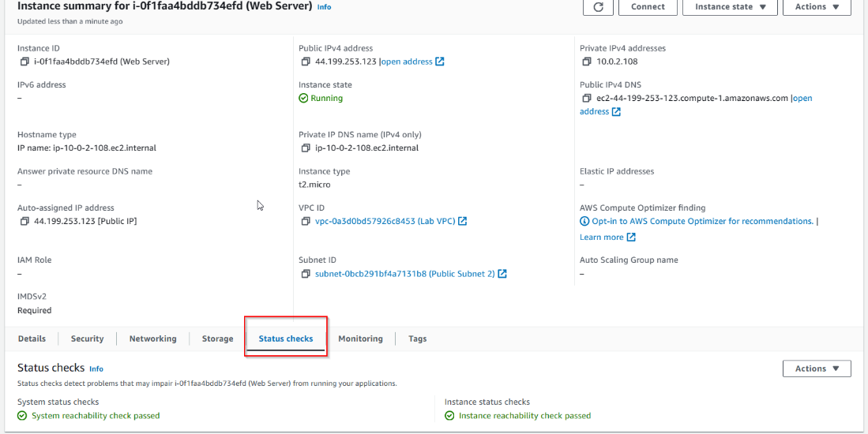

1. Retrieve the Cloudwatch logs through the actions dropdown, and access additional settings such as getting an instance screenshot through the web interface.

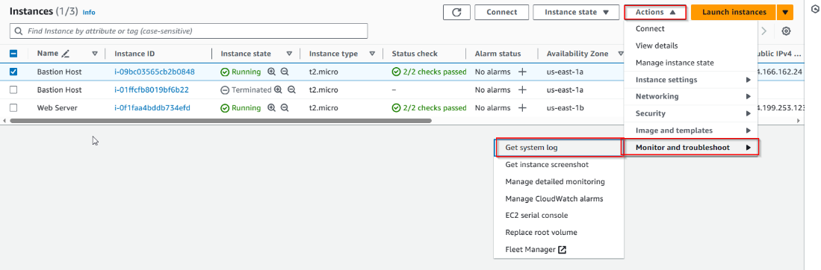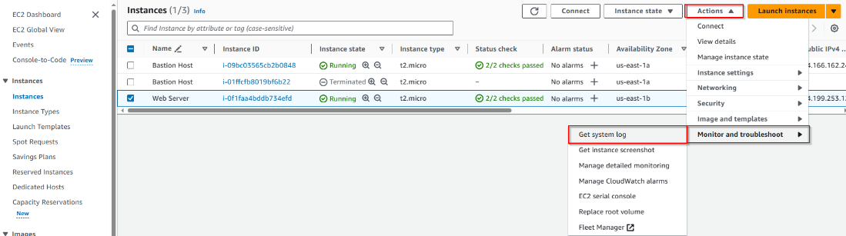

1. Attempt to access the instance through its link, however this is nonfunctional since the security group is blocking port 80.

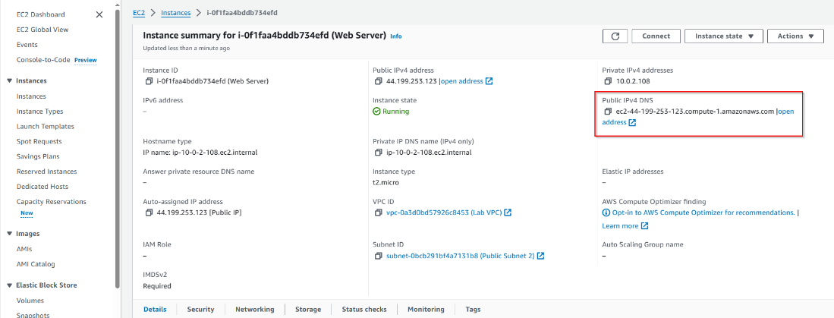

1. Change the security group and edit the inbound rules, adding a rule to allow HTTP.

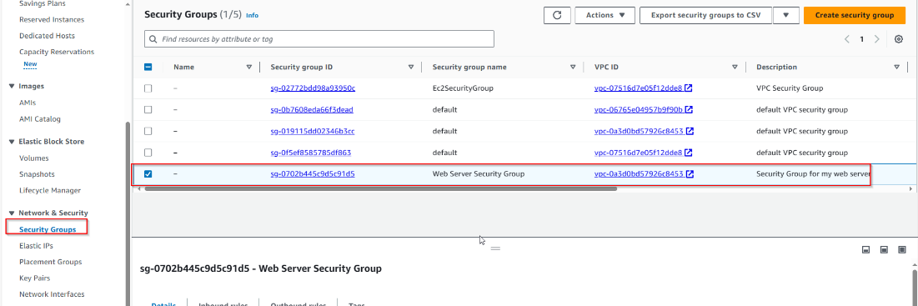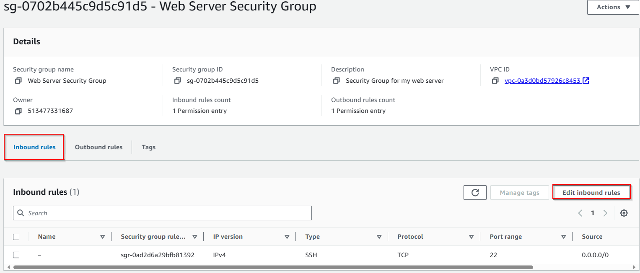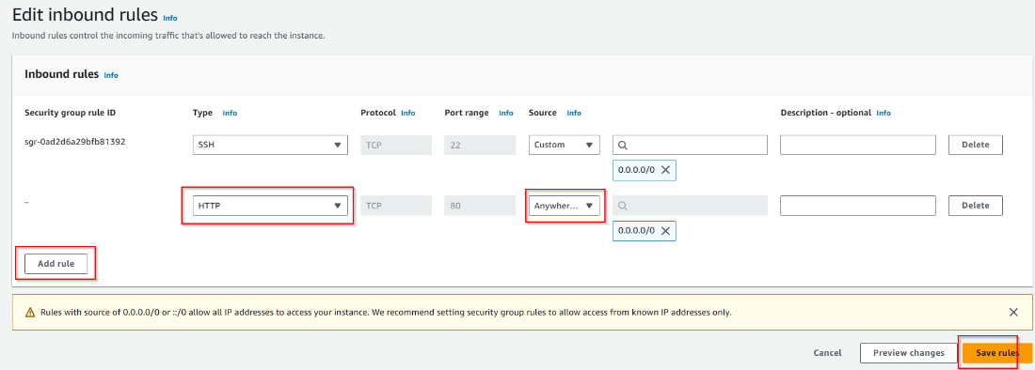

1. Stop your instance and change the type to “t.2 small”.

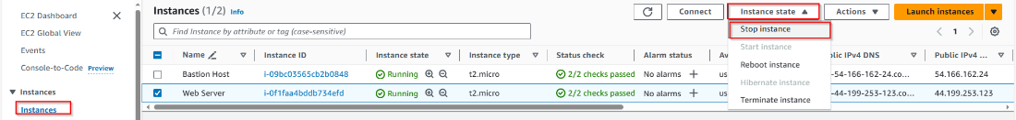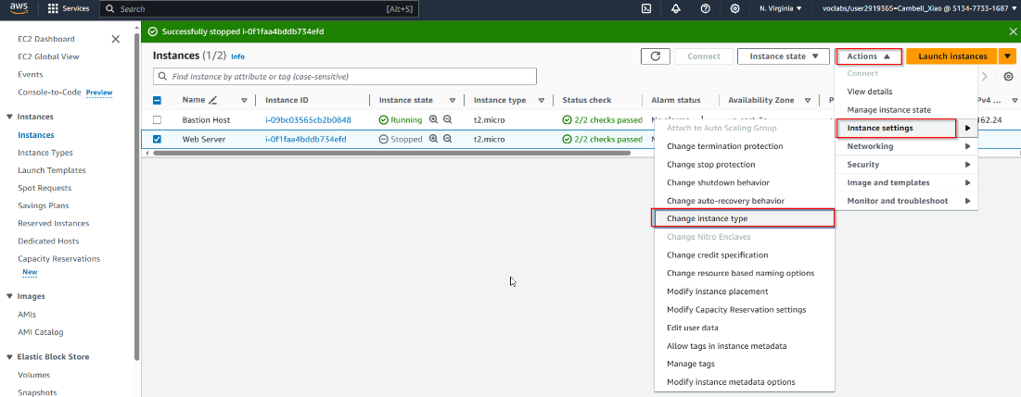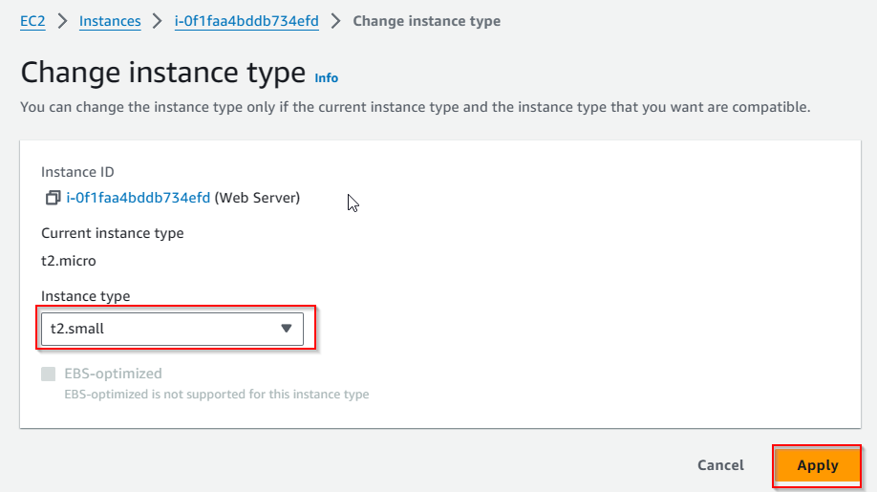

1. Modify the VPC volume to 10 gigs and restart the instance.

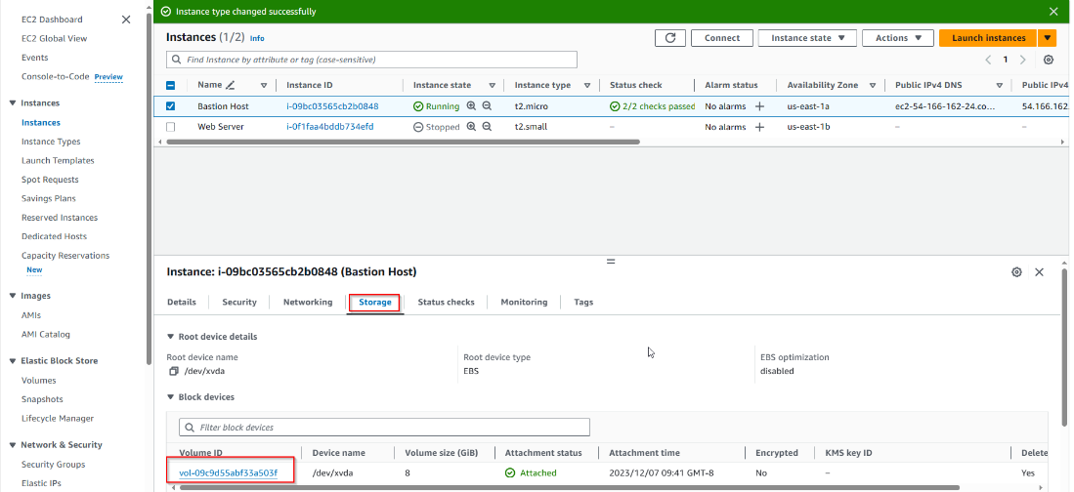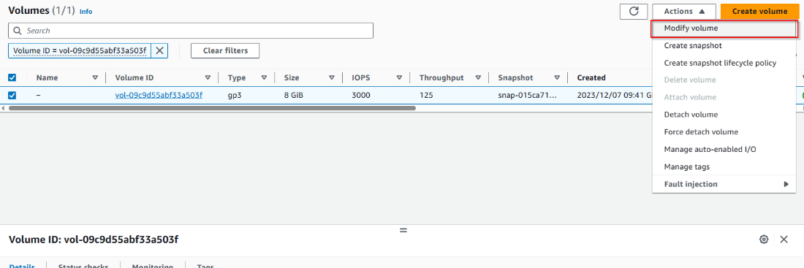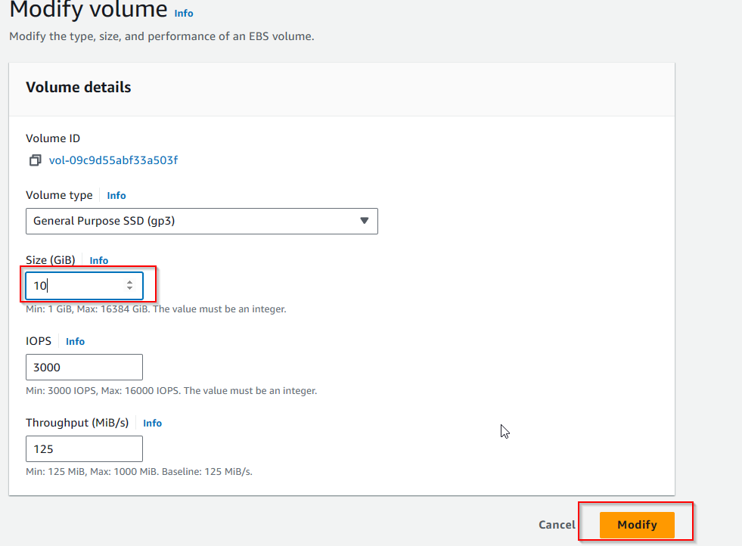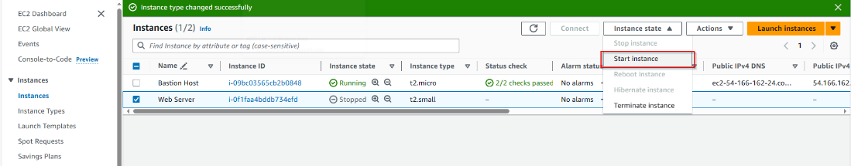

1. Learn about EC2 quotas by searching for run on demand.

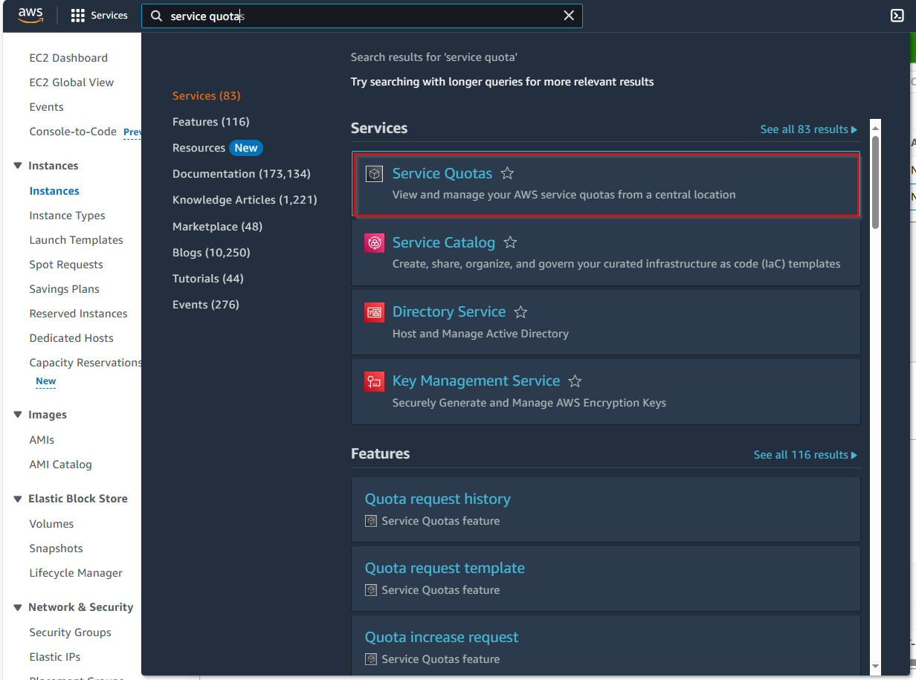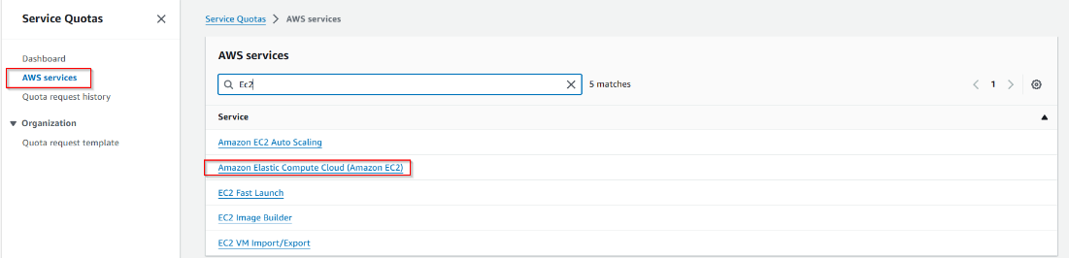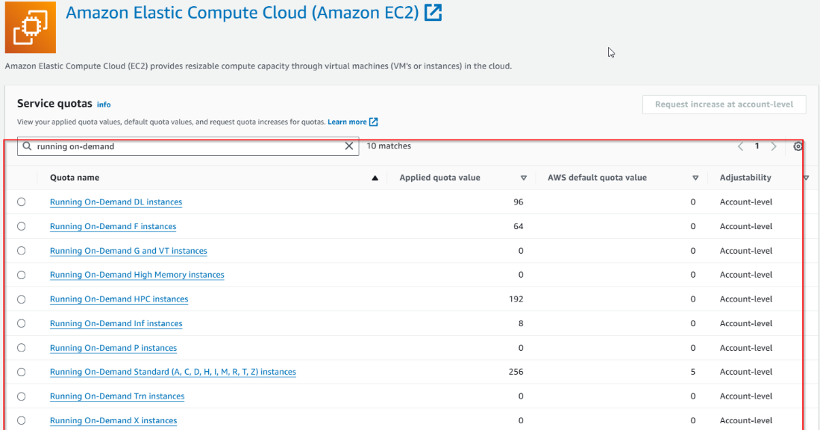

1. Observe termination protection in action by trying to terminate the instance from the web interface. Then, disable termination protection and terminate the instance.

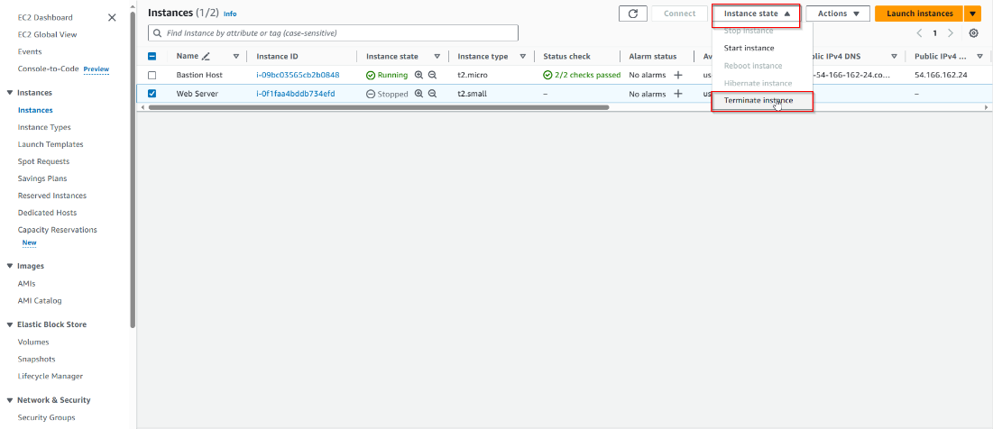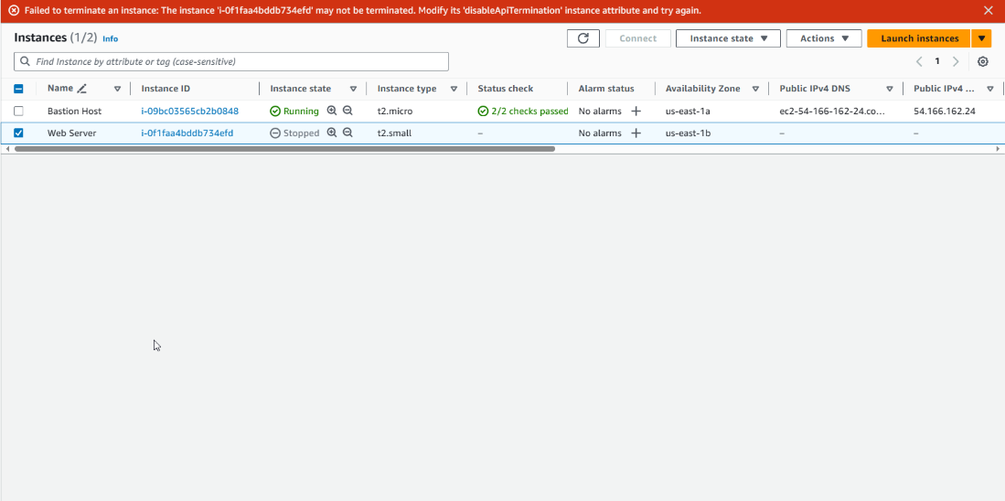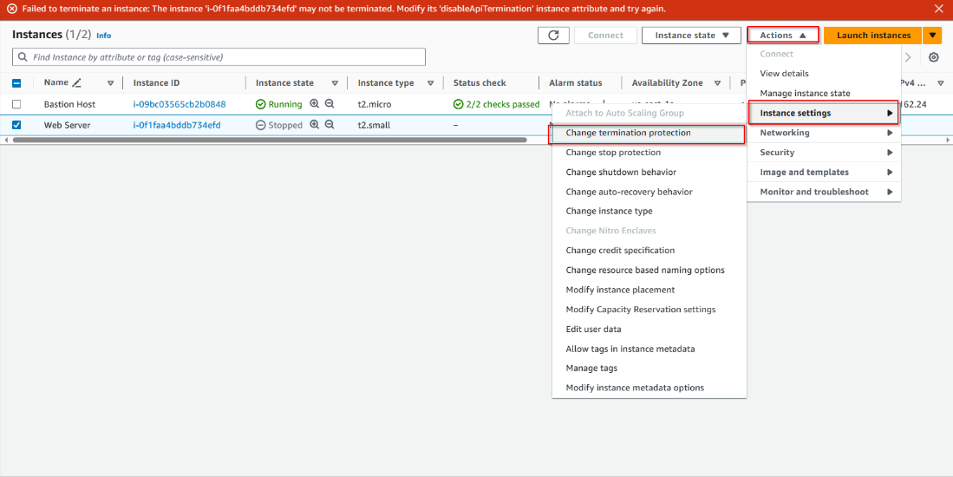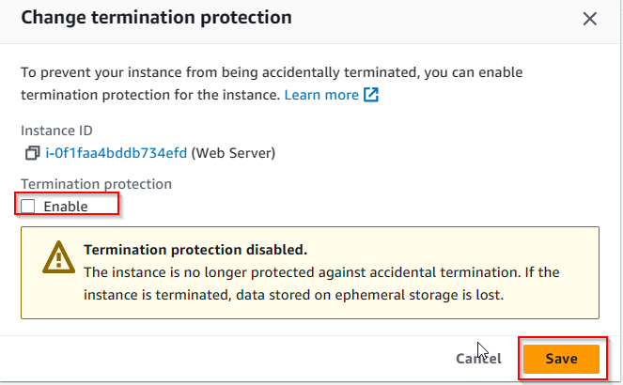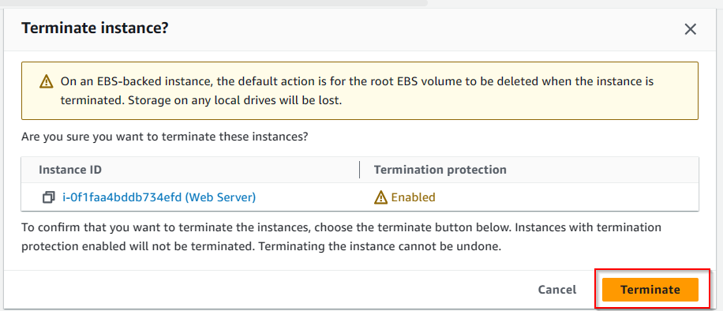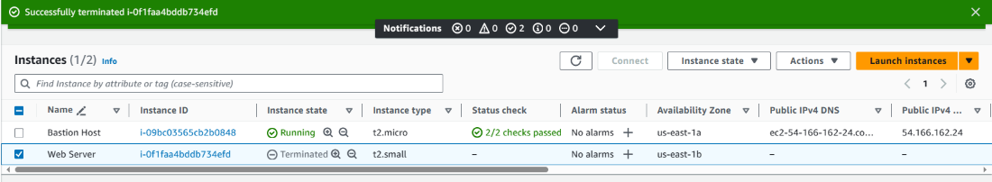

**Conclusion:**

Overall, this lab provided a thorough overview of important AWS concepts and services. Through these three labs, we learned how to configure VPC, IAM, and EC2 services to provide a working web application server. These skills can be transferred to configuring other services, such as the ones demonstrated in further labs 4-6.